A
PROJECT REPORT ON
DEEP LEARNING APPLICATION IN MEDICAL IMAGE ANALYSIS ON BRAIN TUMOR
Submitted in partial fulfillment of the

Requirements for the award of the degree of

MASTER OF COMPUTER APPLICATIONS

By
Mr. M. PENCHALA NARASIMHA,
(Regd.No:225N1F0065).

Under the Guidance of
Mrs. K. VENKATA RAMYA,
Assistant Professor
&
Mr. B.V.SAI KISHORE,
Project leader,

Bits computers, Kadapa.

DEPARTMENT OF COMPUTER APPLICATIONS

ANNAMACHARYA P.G COLLEGE OF COMPUTER STUDIES
NEW BOYANAPALLI-516126, RAJAMPET (A.P)

(Approved by A.I.C.T.E., New Delhi & Affiliated to J.N.T.U.A,
Ananthapuramu, UGC(2f) Recognized Institution)

(2022-2024)

***

ANNAMACHARYA P.G COLLEGE OF COMPUTER STUDIES NEW BOYANAPALLI, RAJAMPETA, A.P, 516126.



Affiliated to

JAWAHARLAL NEHRU TECHNOLOGICAL UNIVERSITY ANANTAPUR, ANANTAPURAMU

DEPARTMENTOF

MASTER OF COMPUTER APPLICATIONS

CERTIFICATE
This is to certify that the project work entitled “Deep Learning Applications In Medical Image Analysis on Brain Tumor” is the bonafide work carried out by Mr. Penchala Narasimha, Regd. No: 225N1F0065, is submitted in partial fulfillment of the requirements for the award of the degree of Master of Computer Applications during the year 2022-2024.

Project Guide Principal

External Examiner

DECLARATION
I, M. PENCHALA NARASIMHA, hereby declare that the project report entitled as “Deep Learning Applications in Medical Image Analysis on Brain Tumor”, done at Bits Computers, Kadapa, is an original and independent record of work, submitted by me to JNTUA, Anantapuramu, under the guidance of Mrs. K. VENKATA RAMYA, Assistant Professor of Annamacharya P.G College of Computer Studies, Rajampet, for the award of the degree of Master of Computer Applications and has not been submitted either in part or in full for the award of any Degree or Diploma.

Place: Rajampet M. Penchala Narasimha,
Date: (Regd.No:215N1F0065).

ACKNOWLEDGEMENT

An endeavor over a long period can be successful only with the advice of many well-wishers. I take this opportunity to express my deep gratitude and appreciation for all those who encouraged me to successfully complete the project.

I wish to express my sincere gratitude to Dr D. J. SAMATHA NAIDU, Principal of Annamacharya P.G College of Computer Studies, New Boyanapalli, Rajampet, for her consistent help and providing such facilities to complete this project.

I express my sincere thanks to my guide Mrs. K. VENKATA RAMYA, Assistant Professor of Annamacharya P.G College of Computer Studies, New Boyanapalli, Rajampet, for his valuable guidance and suggestions in analyzing and testing throughout the period of my project work.

I express my sincere thanks to my guide Mr. B.V.SAI KISHORE, Project leader, Bits Computers, Kadapa, for his valuable guidance and suggestions in analyzing and testing throughout the period of my project work.

Last but not least, I would like to thank my friends, teaching and nonteaching, one and all those who helped me to complete this project successfully.

M. Penchala Narasimha,
(Regd.No:225N1F0065).

ABSTRACT

ABSTRACT
Machine learning algorithms have the potential to be invested deeply in all fields of medicine, from drug discovery to clinical decision making, significantly altering the way medicine is practiced. In existing work, medical images are an integral part of a patient’s EHR and are currently analysed by human radiologists, who are limited by speed, fatigue, and experience. Therefore, it is ideal for medical image analysis to be carried out by an automated, accurate and efficient machine learning algorithm. Yet the situation may not be as dire as it seems, as despite the small training datasets, the papers in this review report relatively satisfactory performance in the various tasks. In proposed work, in medical image analysis is an active field of research for machine learning, partly because the data is relatively structured and labelled, and it is likely that this will be the area where patients first interact with functioning, practical artificial intelligence systems. Firstly, in terms of actual patient metrics, medical image analysis is a litmus test as to whether artificial intelligence systems will actually improve patient outcomes and survival. Secondly, it provides a testbed for human-AI interaction, of how receptive patients will be towards health-altering choices being made, or assisted by a nonhuman actor. In medical image analysis, the lack of data is two-fold and more acute. Most of the datasets presented in this review involve fewer than 100 patients. The question of how many images are necessary for training in medical image analysis was partially answered by ascertained the accuracy of a CNN with GoogleNet architecture in classifying individual axial CT images into one of 6 body regions: brain, neck, shoulder, chest, abdomen, pelvis. With 200 training images, accuracies of test were achieved on a test set of 6000 images. An important, non-technical challenge is the public reception towards their health results being studied by a nonhuman actor.

CONTENTS

Chapters Page No.
- INTRODUCTION 1-3
  - Purpose 1
  - Scope 2
  - Need for System 2
- SOFTWARE REQUIREMENT ANALYSIS
AND SPECIFICATION 4-20
  - Related Work 4
  - System Architecture 6
  - Product Function 6
  - User Constraints 7
  - Hardware Requirements 10
  - Software Requirements 10
  - Non-Functional Requirements 11
- SYSTEM DESIGN 21-45
  - Data Design (Use ER Model) 21
  - Data Dictionary 24
  - UML Design 26
- TESTING 46-60
  - Testing Methodologies 49
  - Test Cases 58
- IMPLEMENTATION 61-82
  - Sample Screens 69

CONCLUSION

BIBLIOGRAPHY
Appendix – A
- URL Listing
- Reference Books
Appendix- B
- Glossary
Appendix- C
- List of Figures
- List of Tables
- List of Screens
Appendix- D
- Coding
- Plagiarism Report

INTRODUCTION

CHAPTER-1

INTRODUCTION
The tremendous success of machine learning algorithms at image recognition tasks in recent years intersects with a time of dramatically increased use of electronic medical records and diagnostic imaging. This review introduces machine learning algorithms as applied to medical image analysis, focusing on convolutional neural networks, and emphasizing clinical aspects of the field. The advantage of machine learning in an era of medical big data is that significant hierarchal relationships within the data can be discovered algorithmically without laborious hand-crafting of features. We cover key research areas and applications of medical image classification, loca j ulization, detection, segmentation and registration. We conclude by discussing research obstacles, emerging trends and possible future directions. Medical image analysis is an active field of research for machine learning, partly because the data is relatively structured and labelled, and it is likely that this will be the area where patients first interact with functioning, practical artificial intelligence systems. This is significant for two reasons. Firstly, in terms of actual patient metrics, medical image analysis is a litmus test as to whether artificial intelligence systems will actually improve patient outcomes and survival. Secondly, it provides a testbed for human-AI interaction, of how receptive patients will be towards health-altering choices being made, or assisted by a non-human actor.

  - PURPOSE
The purpose of developing a machine learning-based system for brain tumor detection is to assist medical professionals in accurately diagnosing brain tumors from medical imaging data such as MRI (Magnetic Resonance Imaging) scans. Early detection of brain tumors is crucial for timely intervention and treatment planning, which can significantly improve patient outcomes. By leveraging machine learning algorithms, this system aims to automate and enhance the diagnostic process, providing clinicians with valuable insights to support clinical decision-making.
  - SCOPE
- Data Collection: Gathering a diverse dataset of MRI scans containing both tumor and non-tumor images from medical institutions or research repositories.
- Data Preprocessing: Preprocessing the MRI images to standardize formats, remove noise, and enhance image quality for better feature extraction.
- Feature Extraction: Extracting relevant features from MRI images using techniques such as image segmentation, texture analysis, and deep learning-based feature learning.
- Model Development: Designing and training machine learning models, including traditional classifiers (e.g., Support Vector Machines, Random Forests) and deep learning architectures (e.g., Convolutional Neural Networks), to classify MRI images as either benign or malignant.
- Model Evaluation: Evaluating the performance of the developed models using metrics such as accuracy, sensitivity, specificity, precision, and area under the ROC curve.
- Clinical Integration: Integrating the developed system into clinical workflows to assist radiologists and oncologists in interpreting MRI scans and making diagnostic decisions.
- Continuous Improvement: Incorporating feedback from medical professionals and updating the system with new data and advancements in machine learning techniques to improve accuracy and reliability over time.

1.3 NEED FOR SYSTEM
Early Detection and Treatment: Brain tumors can be life-threatening if not detected and treated early. A machine learning-based system for brain tumor detection can aid in early diagnosis, allowing for timely intervention and treatment planning, which can significantly improve patient outcomes and survival rates.

Reduced Diagnostic Errors: Human interpretation of medical images such as MRI scans is prone to errors and variability. By automating parts of the diagnostic process, machine learning algorithms can help reduce diagnostic errors, improve consistency, and provide more reliable results.

Resource Optimization: The increasing demand for medical imaging services, coupled with the shortage of radiologists and oncologists, has led to significant workload burdens in healthcare facilities. A machine learning-based system can help optimize resources by assisting healthcare professionals in interpreting MRI scans more efficiently, thereby reducing waiting times for patients.

Personalized Medicine: Different types of brain tumors require different treatment approaches. Machine learning algorithms can analyze imaging data and provide insights into tumor characteristics, helping clinicians tailor treatment plans to individual patients' needs for personalized medicine.

Research and Development: Brain tumor detection using machine learning contributes to ongoing research efforts in the field of medical imaging and oncology. By analyzing large datasets of MRI scans, researchers can gain a better understanding of tumor biology, progression, and treatment response, leading to advancements in diagnosis and therapy.

Global Health Impact: Brain tumors are a significant public health concern worldwide, affecting individuals of all ages and demographics. Developing accessible and accurate tools for brain tumor detection using machine learning can have a positive impact on global health by improving diagnostic capabilities, especially in regions with limited access to specialized medical expertise.
In conclusion, developing a machine learning-based system for brain tumor detection addresses the critical need for accurate and timely diagnosis, reduces diagnostic errors, optimizes healthcare resources, enables personalized treatment approaches, contributes to research efforts, and has a significant impact on global health outcomes.

1.3.1 EXISTING SYSTEM
Parveen, Amritpal Singh [2] purposed algorithm is a combination of SVM and fuzzy c- means, a hybrid technique for prediction of brain tumor. Here, the image is enhanced using contrast improvement, and mid-range stretch. Double thresholding and morphological operations are used for skull striping. Fuzzy c- means (FCM) clustering is used for the image segmentation. Grey level run length matrix (GLRLM) is used for extraction of feature. Another existing method Numerous brain diagnostic systems have been developed using classical ML algorithms including Random Forests (RFs), k-Nearest Neighbor (k-NN), to list a few. These algorithms are used alone or in combination with other ML algorithms or feature selection techniques.

Disadvantages
- It is not possible to detect disease without consultation of doctor.
- It will take more time to calculate our dataset which we having our Brain Tumor dataset.
- Discover patterns using traditional data mining tools may not use for predictions.
- Information can be lost or manipulated in records easily.
- Previous applications were not 100 percent accurate and this leads to in accurate information of disease.

1.3.2 PROPOSED SYSTEM
This project is aimed at developing an application called Brain Tumor Detection system based on MRI dataset. Magnetic resonance imaging (MRI) is the most useful imaging tool in the evaluation of patients with brain tumors. A deep learning based technique (Convolutional Neural Network) was proposed in this model. The proposed Convolutional Neural Network (CNN) model was being tested using different image segmentation methods and different datasets. Finally, the best image segmentation method obtained a high accuracy of around 96%. Results of those experiments suggest an important role for the early diagnosis of Brain tumor using image processing and deep learning techniques. Our application is 96 percent accurate and it is fast, robust, reliable and easy to use.
After examining many algorithms for detecting brain tumors, we found that most algorithms required a long computational time, while cheap computational time methods could not provide great accuracy. Another downside is that scaling up the process is nearly impossible because each estimator is based on the accuracy of preceding predictors. As a result, we intended to propose an approach that could provide excellent accuracy.

Advantages
- It helps patient to detect and find stage of Brain Tumor easily.
- Minimal time, cost and effort spent.
- Discover patterns using machine learning algorithm that identify the best mode of treatment for Tumor across different age.
- This application can recognize different MRI images with high accuracy.
- The application is fast, robust, reasonably simple and accurate with a relatively simple and easy to understand algorithms and technique.

SOFTWARE REQURIEMENTS SPECIFICATION

CHAPTER-2
SOFTWARE REQURIEMENTS ANALYSIS AND SPECIFICATIONS
2.1 RELATED WORK
This section discusses the survey papers on medical image analysis using deep learning-based algorithms. Hu et al. [9] described four deep learning architectures used for image analysis: CNN, fully convolutional networks (FCN), deep belief networks, and autoencoders. They also compiled recent works on cancer identification and diagnosis.
Liu et al. [10] concentrated on deep learning-based medical image segmentation. They began by explaining the deep learning framework deployed to segment medical images. Then, state-of-the-art segmentation architectures such as FCN, U-Net, and generative adversarial network (GAN) were examined.
Shin et al. [11] first studied two medical diagnostic problems, namely, interstitial lung disease detection and thoracoabdominal lymph node classification, using three CNN models: AlexNet, CifarNet, and GoogLeNet. Then looked at how transfer learning enhanced the performance of each model.
Kazeminia et al. [12] provided a broad insight into the current studies on GANs for medical applications, discussed the limitations and opportunities of the existing techniques, and elaborated on potential future work.
Fu et al. [13] highlighted the current advancements in medical image segmentation by deep learning. They divided the approaches reviewed into two main groups: pixel-by-pixel classification and end-to-end segmentation, and discussed the performance, limits, and future potential of each group.

2.1.1 LITERACTURE SURVEY
1. E.-S. A. El-Dahshan, H. M. Mohsen, K. Revett, and A.-B. M. Salem, “Computer-aided diagnosis of human brain tumor through MRI: a survey and a new algorithm,” Expert Systems with Applications, vol. 41, no. 11, pp. 5526–5545, 2014.
Computer-aided detection/diagnosis (CAD) systems can enhance the diagnostic capabilities of physicians and reduce the time required for accurate diagnosis. The objective of this paper is to review the recent published segmentation and classiﬁcation techniques and their state-of-the-art for the human brain magnetic resonance images (MRI). The review reveals the CAD systems of human brain MRI images are still an open problem. In the light of this review, we proposed a hybrid intelligent machine learning technique for computer-aided detection system for automatic detection of brain tumor through magnetic resonance images. The proposed technique is based on the following computational methods; the feedback pulse-coupled neural network for image segmentation, the discrete wavelet transforms forfeitures extraction, the principal component analysis for reducing the dimensionality of the wavelet coefﬁcients, and the feed forward back-propagation neural network to classify inputs into normal or abnormal. The experiments were carried out on 101 images consisting of 14 normal and 87 abnormal (malignant and benign tumors) from a real human brain MRI dataset. The classiﬁcation accuracy on both training and test images is 99% which was signiﬁcantly good. Moreover, the proposed technique demonstrates its effectiveness compared with the other machine learning recently published techniques. The results revealed that the prop.

2. E. I. Zacharaki, S. Wang, S. Chawla et al., “Classification of brain tumor type and grade using MRI texture and shape in a machine learning scheme,” Magnetic Resonance in Medicine, vol. 62, no. Issue 4, pp. 1609–1618, 2009.
The objective of this study is to investigate the use of pattern classification methods for distinguishing different types of brain tumors, such as primary gliomas from metastases, and also for grading of gliomas. The availability of an automated computer analysis tool that is more objective than human readers can potentially lead to more reliable and reproducible brain tumor diagnostic procedures. A computer-assisted classification method combining conventional MRI and perfusion MRI is developed and used for differential diagnosis. The proposed scheme consists of several steps including ROI definition, feature extraction, feature selection and classification. The extracted features include tumor shape and intensity characteristics as well as rotation invariant texture features. Feature subset selection is performed using Support Vector Machines (SVMs) with recursive feature elimination. The method was applied on a population of 102 brain tumors histologically diagnosed as metastasis (24), meningiomas (4), gliomas WHO grade 2 (22), gliomas WHO grade 3 (18), and glioblastomas (34). The binary SVM classification accuracy, sensitivity, and specificity, assessed by leave-one-out cross-validation, were respectively 85%, 87%, and 79% for discrimination of metastases from gliomas, and 88%, 85%, and 96% for discrimination of high grade (grade III and IV) from low grade (grade II) neoplasms. Multi-class classification was also performed via a one-versus-all voting scheme.

3. A. I şın, C. Direko ğlu, and M. Şah, “Review of MRI-based brain tumor image segmentation using deep learning methods,” Procedia Computer Science, vol. 102, pp. 317–324, 2016.
In this paper, an autonomous brain tumor segmentation and detection model is developed utilizing a convolutional neural network technique that included a local binary pattern and a multilayered support vector machine. The detection and classification of brain tumors are a key feature in order to aid physicians; an intelligent system must be designed with less manual work and more automated operations in mind. During feature extraction, the RGB image is converted to a binary image by grayscale conversion via the colormap process, and this process is then completed by the local binary pattern (LBP). To extract feature information, a convolutional network can be utilized, while to detect objects, a multilayered support vector machine (ML-SVM) can be employed. CNN is a popular deep learning algorithm that is utilized in a wide variety of engineering applications. Finally, the classification approach used in this work aids in determining the presence or absence of a brain tumor. To conduct the comparison, the entire work is tested against existing procedures and the proposed approach using critical metrics such as dice similarity coefficient (DSC), Jaccard similarity index (JSI), sensitivity (SE), accuracy (ACC), specificity (SP), and precision (PR).

4. P. Thejaswini, M. B. Bhat, and M. K. Prakash, “Detection and classification of tumor in brain MRI,” International Journal of Engineering and Manufacturing (IJEM), vol. 9, no. 1, pp. 11–20, 2019.
Brain Tumor is an abnormal cell formation inside the brain. They are mainly classified as benign and malignant tumors. Magnetic Resonance Imaging (MRI) is used for effective diagnosis of brain tumor. An automated method for detection and classification of brain tumor is preferred as analysis of MRI manually is a difficult task for medical experts. The proposed method uses Adaptive Regularized Kernel based Fuzzy CMeans Clustering (ARKFCM) for segmentation. A combination of Support Vector Machine (SVM) and Artificial Neural Network (ANN) is proposed for detection and classification of brain tumor based on the extracted features. A dataset of 94 images is considered for validation of the proposed method which resulted in an accuracy of 91.4%, Sensitivity of 98%, Specificity of 78% and Bit Error Rate (BER) of 0.12. Comparison of the proposed method is carried out with other conventional methods and the results are tabulated.
5. K. SUDHARANI, Dr. T. C. SARMA, Dr. K. SATYA RASAD “Intelligent Brain Tumour Lesion Classification and Identification from MRI Images Using k-NN Technique” in International Conference on Control, Instrumentation, Communication and Computational Technologies(lCCICCT)2015.
The Magnetic Resonance Imaging (MRI), and Computed Tomography (CT) provides scanned images for Brain Tumor detection. Growth of abnormal cells in uncontrolled manner is tumor. The present paper proposed the classification and identification scores of brain tumor by using k-NN algorithm which is based on training of k. In this work Manhattan metric has applied and calculated the distance of the classifier. The algorithm has been implemented using the Lab View.

6. G. Litjens, T. Kooi, B. E. Bejnordi, A. A. A. Setio, F. Ciompi, M. Ghafoorian, J. A. van der Laak, B. van Ginneken, and C. I. Sánchez, “A survey on deep learning in medical image analysis,” arXiv preprint arXiv:1702.05747, 2017.
Deep learning algorithms, in particular convolutional networks, have rapidly become a methodology of choice for analyzing medical images. This paper reviews the major deep learning concepts pertinent to medical image analysis and summarizes over 300 contributions to the field, most of which appeared in the last year. We survey the use of deep learning for image classification, object detection, segmentation, registration, and other tasks. Concise overviews are provided of studies per application area: neuro, retinal, pulmonary, digital pathology, breast, cardiac, abdominal, musculoskeletal. We end with a summary of the current state-of-the-art, a critical discussion of open challenges and directions for future research.

7. K. Suzuki, “Overview of deep learning in medical imaging,” Radiological Physics and Technology, vol. 10, no. 3, pp. 257–273, 2017.
The use of machine learning (ML) has been increasing rapidly in the medical imaging field, including computer-aided diagnosis (CAD), radiomics, and medical image analysis. Recently, an ML area called deep learning emerged in the computer vision field and became very popular in many fields. It started from an event in late 2012, when a deep-learning approach based on a convolutional neural network (CNN) won an overwhelming victory in the best-known worldwide computer vision competition, ImageNet Classification. The class of ML with image input (or image-based ML) including deep learning has a long history, but recently gained popularity due to the use of the new terminology, deep learning. There are two major models in this class of ML in medical imaging, MTANN and CNN, which have similarities as well as several differences. In our experience, MTANNs were substantially more efficient in their development, had a higher performance, and required a lesser number of training cases than did CNNs. "Deep learning", or ML with image input, in medical imaging is an explosively growing, promising field. It is expected that ML with image input will be the mainstream area in the field of medical imaging in the next few decades.

8. D. Shen, G. Wu, and H.-I. Suk, “Deep learning in medical image analysis,” Annual Review of Biomedical Engineering, no. 0, 2017.
This review covers computer-assisted analysis of images in the field of medical imaging. Recent advances in machine learning, especially with regard to deep learning, are helping to identify, classify, and quantify patterns in medical images. At the core of these advances is the ability to exploit hierarchical feature representations learned solely from data, instead of features designed by hand according to domain-specific knowledge. Deep learning is rapidly becoming the state of the art, leading to enhanced performance in various medical applications. We introduce the fundamentals of deep learning methods and review their successes in image registration, detection of anatomical and cellular structures, tissue segmentation, computer-aided disease diagnosis and prognosis, and so on. We conclude by discussing research issues and suggesting future directions for further improvement.

9. X. Wang, Y. Peng, L. Lu, Z. Lu, M. Bagheri, and R. M. Summers, “Chestx-ray8: Hospital-scale chest x-ray database and benchmarks on weakly-supervised classification and localization of common thorax diseases,” arXiv preprint arXiv:1705.02315, 2017.
The chest X-ray is one of the most commonly accessible radiological examinations for screening and diagnosis of many lung diseases. A tremendous number of X-ray imaging studies accompanied by radiological reports are accumulated and stored in many modern hospitals' Picture Archiving and Communication Systems (PACS). In this paper, we present a new chest X-ray database, namely "ChestX-ray8", which comprises 108,948 frontal-view X-ray images of 32,717 unique patients with the text-mined eight disease image labels (where each image can have multi-labels), from the associated radiological reports using natural language processing. Although the initial quantitative results are promising as reported, deep convolutional neural network based "reading chest X-rays" (i.e., recognizing and locating the common disease patterns trained with only image-level labels) remains a strenuous task for fully-automated high precision CAD systems.

2.2 RESEARCH METHODOLOGY

2.2.1 SYSTEM ARCHITECTURE

Fig 2.2.1: Research Methodology

In above figure, Pre-processing involves processes like conversion to grayscale image, noise removal and image reconstruction. Conversion to grey scale image is the most common pre-processing practice. After the image is converted to grayscale, then remove excess noise using different filtering methods. Segmentation of images is important as large numbers of images are generated during the scan and it is unlikely for clinical experts to manually divide these images in a reasonable time. Feature extraction is an important step in the construction of any pattern classification and aims at the extraction of the relevant information that characterizes each class. Classification is the best approaches for identification of images like any kind of medical imaging. All classification algorithms are based on the prediction of image, where one or more features and that each of these features belongs to one of several classes. Classification is used to classify each item in a set of data into one of predefined set of classes or groups.

2.2.2 PROPOSED ALGORITHMS

CONVOLUTIONAL NEURAL NETWORK
Convolutional Neural Network is one of the main categories to do image classification and image recognition in neural networks. Scene labeling, objects detections, and face recognition, etc., are some of the areas where convolutional neural networks are widely used. CNN takes an image as input, which is classified and process under a certain category such as dog, cat, lion, tiger, etc. The computer sees an image as an array of pixels and depends on the resolution of the image. Based on image resolution, it will see as h * w * d, where h= height w= width and d= dimension. For example, An RGB image is 6 * 6 * 3 array of the matrix, and the grayscale image is 4 * 4 * 1 array of the matrix.
In CNN, each input image will pass through a sequence of convolution layers along with pooling, fully connected layers, filters (Also known as kernels). After that, we will apply the Soft-max function to classify an object with probabilistic values 0 and 1.
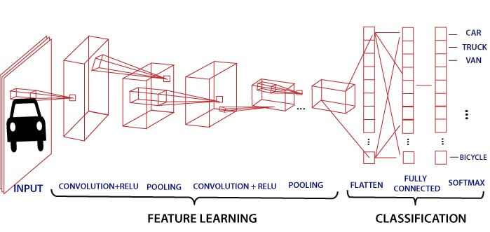

Convolution Layer
Convolution layer is the first layer to extract features from an input image. By learning image features using a small square of input data, the convolutional layer preserves the relationship between pixels. It is a mathematical operation which takes two inputs such as image matrix and a kernel or filter.
- The dimension of the image matrix is h×w×d.
- The dimension of the filter is f_{h}×f_{w}×d.
- The dimension of the output is (h-f_{h}+1)×(w-f_{w}+1)×1.
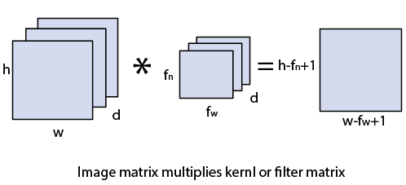
Let's start with consideration a 5*5 image whose pixel values are 0, 1, and filter matrix 3*3 as:
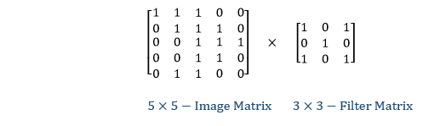
The convolution of 5*5 image matrix multiplies with 3*3 filter matrix is called "Features Map" and show as an output.
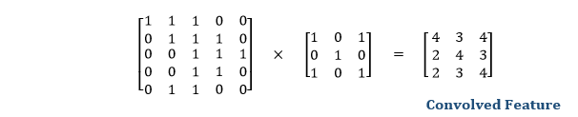
Convolution of an image with different filters can perform an operation such as blur, sharpen, and edge detection by applying filters.

Strides
Stride is the number of pixels which are shift over the input matrix. When the stride is equaled to 1, then we move the filters to 1 pixel at a time and similarly, if the stride is equaled to 2, then we move the filters to 2 pixels at a time. The following figure shows that the convolution would work with a stride of 2.
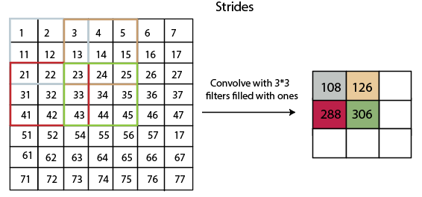

Padding
Padding plays a crucial role in building the convolutional neural network. If the image will get shrink and if we will take a neural network with 100's of layers on it, it will give us a small image after filtered in the end.
If we take a three by three filter on top of a grayscale image and do the convolving then what will happen?
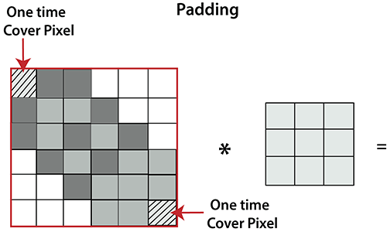

It is clear from the above picture that the pixel in the corner will only get covers one time, but the middle pixel will get covered more than once. It means that we have more information on that middle pixel, so there are two downsides:
- Shrinking outputs.
- Losing information on the corner of the image.
To overcome this, we have introduced padding to an image. "Padding is an additional layer which can add to the border of an image."

Pooling Layer
Pooling layer plays an important role in pre-processing of an image. Pooling layer reduces the number of parameters when the images are too large. Pooling is "downscaling" of the image obtained from the previous layers. It can be compared to shrinking an image to reduce its pixel density. Spatial pooling is also called downsampling or subsampling, which reduces the dimensionality of each map but retains the important information. There are the following types of spatial pooling:

Max Pooling
Max pooling is a sample-based discretization process. Its main objective is to downscale an input representation, reducing its dimensionality and allowing for the assumption to be made about features contained in the sub-region binned.
Max pooling is done by applying a max filter to non-overlapping sub-regions of the initial representation.
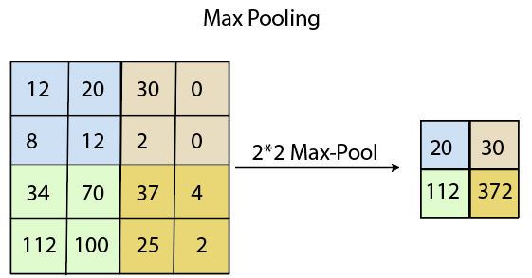
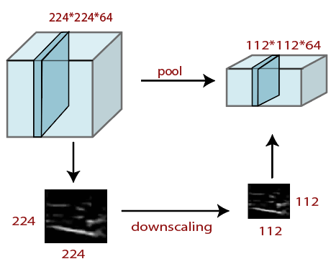

Average Pooling
Down-scaling will perform through average pooling by dividing the input into rectangular pooling regions and computing the average values of each region.
Syntax
layer = averagePooling2dLayer(poolSize)
layer = averagePooling2dLayer(poolSize,Name,Value)

Sum Pooling
The sub-region for sum pooling or mean pooling are set exactly the same as for max-pooling but instead of using the max function we use sum or mean.

Fully Connected Layer
The fully connected layer is a layer in which the input from the other layers will be flattened into a vector and sent. It will transform the output into the desired number of classes by the network.
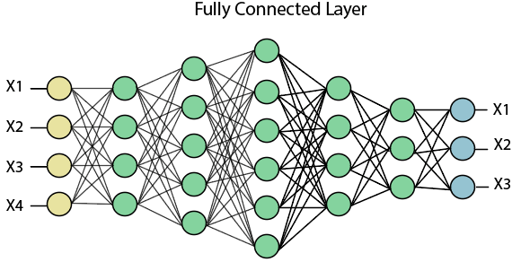
In the above diagram, the feature map matrix will be converted into the vector such as x1, x2, x3... xn with the help of fully connected layers. We will combine features to create a model and apply the activation function such as softmax or sigmoid to classify the outputs as a car, dog, truck, etc.
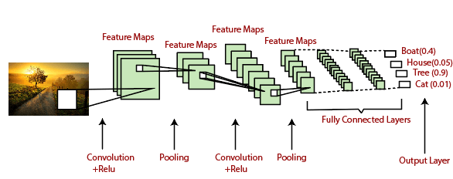
2.3 PROPOSED MODULES
Input Image
The Brain MRI image dataset has been downloaded from the Kaggle. The MRI dataset consists of around 255 MRI images, including tumor and non-tumor images. These MRI images are taken as input to the primary step.

Data Augmentation
Image data augmentation is a technique that can be used to artificially expand the size of a training dataset by creating modified versions of images in the dataset. Training deep learning neural network models on more data can result in more skillful models, and the augmentation techniques can create variations of the images that can improve the ability of the fit models to generalize what they have learned to new images. The Keras deep learning neural network library provides the capability to fit models using image data augmentation via the Image Data Generator class.
Data Set of MRI images is collected from Kaggle website which has 255 MRI Images. So, after data augmentation it is increased to around 2063 images.
Image Pre-processing
The pre-processing is an essential and initial step in improving the quality of the brain MRI Image. The critical steps in pre-processing are the reduction of impulsive noises and image resizing. In the initial phase, we convert the brain MRI image into its corresponding grayscale image. The removal of unwanted noise is done using the adaptive bilateral filtering technique to remove the distorted noises that are present in the brain picture. This improves the diagnosis and also increase the classification accuracy rate.

Image segmentation using binary threshold
Image segmentation is a technique of segregating the image into many parts. The basic aim of this segregation is to make the images easy to analyze and interpret with preserving the quality. This technique is also used to trace the objects’ borders within the images. This technique labels the pixels according to their intensity and characteristics. Those parts represent the entire original image and acquire its characteristics such as intensity and similarity. The image segmentation technique is used to create contours of the body for clinical purposes. Segmentation is used in machine perception, malignant disease analysis, tissue volumes, anatomical and functional analyses, virtual reality visualization, and anomaly analysis, and object definition and detection. Segmentation methods has ability to detect or identify the abnormal portion from the image which is useful for analyzing the size, volume, location, texture and shape of the extracted image. MRI image segmentation with the aid of preserving the threshold information, which is convenient to identify the broken regions extra precisely. It was a trendy surmise that the objects that are placed in close propinquity might be sharing similar houses and characteristics.

Morphological operation
Morphological operations apply a structuring element to an input image, creating an output image of the same size. In a morphological operation, the value of each pixel in the output image is based on a comparison of the corresponding pixel in the input image with its neighbors.

Brain Tumor Image Classification Using Convolution Neural Network
Classification is the best approaches for identification of images like any kind of medical imaging. All classification algorithms are based on the prediction of image, where one or more features and that each of these features belongs to one of several classes. An automatic and reliable classification method Convolutional Neural Network (CNN) will be used since it is robust in structure which helps in identifying every minute details. A Convolutional Neural Network (ConvNet/CNN) is a Deep Learning algorithm which can take in an input image, assign importance to various aspects/objects in the image and be able to differentiate one from the other. The pre-processing required in a ConvNet is much lower as compared to other classification algorithms. While in primitive methods filters are hand- engineered, with enough training, ConvNet have the ability to learn these filters/characteristics.
- Sequential is used to initialize the neural network.
- Convolution2D is used to make the convolutional network that deals with the images.
- MaxPooling2D layer is used to add the pooling layers.
- Flatten is the function that converts the pooled feature map to a single column that is passed to the fully connected layer.
- Dense adds the fully connected layer to the neural network.

Materials and Methods

Training dataset
In this project, to tune up the object detection model for human detection under various low light conditions, a recently released ExDARK dataset is considered which specifically focuses on a low-light environment. In this dataset, 12 different classes of objects are labeled, out of which we fetched data of our desired class for training. This dataset contains different indoor and outdoor low light images; furthermore, the data is subdivided for low light environment into 10 classes ambient, object, strong, twilight, low, weak, screen, window, shadow, and single. Sample images of various indoor-outdoor low-light environments from the dataset.

Testing Dataset
A custom dataset is used for the evaluation of the proposed model. The dataset is collected from the market of Rawalpindi, Pakistan during the night in the days of COVID-19. Pakistan is one of the most urbanized countries in South Asia with a 3% yearly urban population growth rate. The large population and congested streets make it a riskier place in the growth of COVID-19 and it is very difficult to maintain safety distance in such narrow places. Hence, the monitoring system should need to have high accuracy in terms of the detection and location of the people. Evaluation of the proposed framework in such a highly-populated area will help us to better analyze the performance of the model. Test dataset is the collection of 346 RGB frames. Frames are collected with motionless ToF camera of Samsung galaxy note 10+ installed 4.5 feet above the ground where a 0° regular camera view calibration is adopted. Sample images of low-light conditions from the custom dataset.
2.4 USER CONSTRAINTS
User Constraints for project is analyzed in this phase and business proposal is put forth with a very general plan for the project and some cost estimates. During system analysis the feasibility study of the proposed system is to be carried out. This is to ensure that the proposed system is not a burden to the company. For feasibility analysis, some understanding of the major requirements for the system is essential.
- Economical Constraints.
- Technical Constraints.
- Social Constraints.

- ECONOMICAL CONSTRAINTS
This study is carried out to check the economic impact that the system will have on the organization. The amount of fund that the company can pour into the research and development of the system is limited. The expenditures must be justified. Thus the developed system as well within the budget and this was achieved because most of the technologies used are freely available. Only the customized products had to be purchased.

TECHNICAL CONSTRAINTS
This study is carried out to check the technical feasibility, that is, the technical requirements of the system. Any system developed must not have a high demand on the available technical resources. This will lead to high demands on the available technical resources. This will lead to high demands being placed on the client. The developed system must have a modest requirement, as only minimal or null changes are required for implementing this system.

- SOCIAL CONSTRAINTS
The aspect of study is to check the level of acceptance of the system by the user. This includes the process of training the user to use the system efficiently. The user must not feel threatened by the system, instead must accept it as a necessity. The level of acceptance by the users solely depends on the methods that are employed to educate the user about the system and to make him familiar with it. His level of confidence must be raised so that he is also able to make some constructive criticism, which is welcomed, as he is the final user of the system.

2.5 HARDWARE REQUIREMENTS
Processor : I3 or higher
Speed : 2.9 GHz
RAM : 4 GB (min)
Hard Disk : 160 GB
2.6 SOFTWARE REQUIREMENTS
- Operating system : Windows 7 Ultimate
- Coding Language : Python
- Back-End : Django-ORM
- Designing : HTML, CSS, JavaScript
- Data Base : MySQL (WAMP Server)

2.7 FUNCTIONAL REQUIREMENTS
Functional requirements describe what the system should do. The functional requirements can be further categorized as follows:
- What inputs the system should accept?
- What outputs the system should produce?
- What data the system must store?
- What are the computations to be done?

The input design is the link between the information system and the user. It comprises the developing specification and procedures for data preparation and the steps are necessary to put transaction data in to a usable form for processing that can be achieved by inspecting the computer to read data from a written or printed document or it can occur by having people keying the data directly into the system. The design of input focuses on controlling the amount of input required, controlling the errors, avoiding delay, avoiding extra steps and keeping the process simple. The input is designed in such a way so that it provides security and ease of use with retaining the privacy. Input Design considered the following things:
- What data should be given as input?
- How the data should be arranged or coded?
- The dialog to guide the operating personnel in providing input.
- Methods for preparing input validations and steps to follow when error occur.

2.8 NON-FUNCTIONAL REQUIREMENTS
Non-functional requirements are the constraints that must be adhered during development. They limit what resources can be used and set bounds on aspects of the software’s quality.

User Interfaces
The User Interface is a GUI developed using Python.

Software Interfaces
The main processing is done in Java and console application.

Manpower Requirements
5 members can complete the project in 2 – 4 months if they work fulltime on it.

SYSTEM DESIGN

CHAPTER-3
SYSTEM DESIGN
3.1 Database Design (E-R Diagram)

An Entity-Relationship (ER) model illustrates the structure of a database using a visual representation known as an Entity-Relationship Diagram (ER Diagram). This model serves as a blueprint for designing the database schema and capturing the relationships between different entities and attributes.

The ER model provides a systematic approach to organizing and conceptualizing the data within a database system. It represents entities as well as the relationships between them, helping to clarify how data elements are connected and organized.

3.1.1 ER Model

- The Emergency Room model corresponds to an Entity-Relationship model, serving as a high-level representation of data structures. It is utilized to illustrate the data components and relationships within a defined system.
- It establishes a structured framework for the database. Moreover, it provides a straightforward and easily understandable perspective on the data.
- In Entity-Relationship modeling, the organizational database structure is depicted through a design known as an Entity-Relationship diagram.
- For instance, consider designing a school database. An educational record could be represented as an entity with attributes such as name, ID, age, etc. Similarly, the address could be another entity with attributes like city, street name, zip code, etc., and there would be a relationship between them.

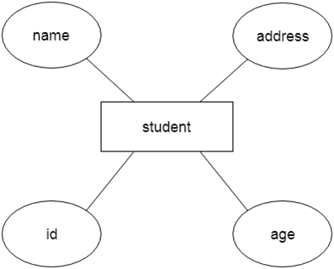
Fig 3.1 ER-Model

Component of ER Diagram

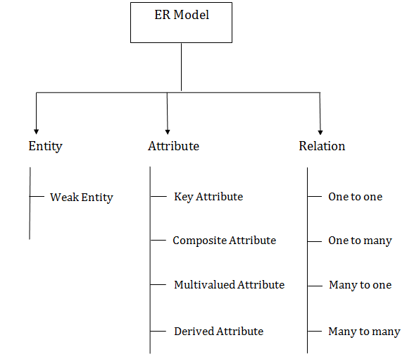

1. Entity

A substance may be anything, class, individual or spot. In the ER frame, a substance can be tended to as square shapes.
Think about a relationship as a delineation chief, thing, specialist, office, etc can be taken as a substance.

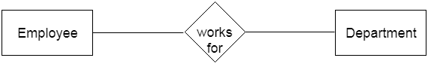
2. Powerless Entity
A substance that depends upon another component called a frail substance. The frail element contains no critical trait of its own. The feeble substance is addressed by a twofold square shape.

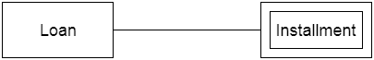

3. Characteristic

The quality is utilized to depict the property of a section. Obscure is utilized to address a quality.
For example, id, age, contact number, name, etc can be attributes of a student.
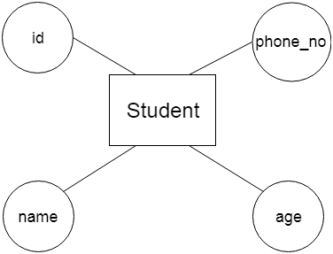

a. Key Attribute
The key quality is used to address the essential ascribes of a substance. It tends to a fundamental key. The key property is tended to by a circle with the text underlined.

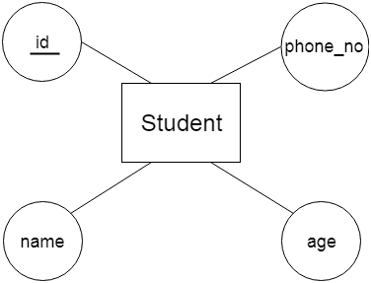
b. Composite Attribute
A property that made from various attributes is known as a composite quality. The composite trademark is tended to by an oval, and those circles are related with a circle.
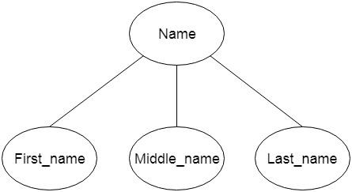

c. Multivalued Attribute
A quality can have more than one worth. These qualities are known as a multivalued property. The twofold oval is used to address multivalued property. For example, a student can have more than one phone number.
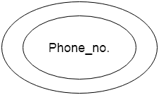
d. Determined Attribute
A property that can be gotten from another quality is known as a decided attribute. It will in general be tended to by a ran circle.
For example, a singular's age changes long term and can be gotten from one more quality like Date of birth.
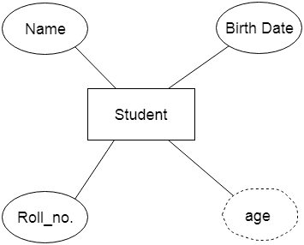
4. Relationship
A relationship is used to depict the connection between substances. Important stone or rhombus is utilized to address the relationship.
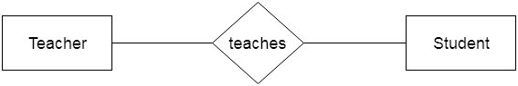

Sorts of relationship are as per the following:
a. One-to-One relationship
At the point when just a single instance of a component is connected with the relationship, then it is known as facilitated relationship.For instance, A female can wed to one male, and a male can wed to one female.


b. One-to-Many relationship
Exactly when simply a solitary illustration of the substance on the left, and more than one event of a component on the right associates with the relationship then this is known as a one-to-various connections.
For example, Scientist can envision various manifestations, but the improvement is done by the really express analyst.

Remote user
has
Tweet server
1 1 :M M

c. Many-to-One relationship
Exactly when more than one event of the component on the left, and simply a solitary event of a substance on the right associates with the relationship then it is known as a many-to-one relationship.
For example, Student enrols for only a solitary course, but a course can have various students.

Request
user
Service provider
1 M

d. Many-to-many relationship
At the point when more than one event of the substance on the left, and more than one event of a component on the right associates with the relationship then it is known as a many-to-various connections.
For example, Employee can allot by numerous exercises and project can have various specialists.

users
logins
has
M M M :M

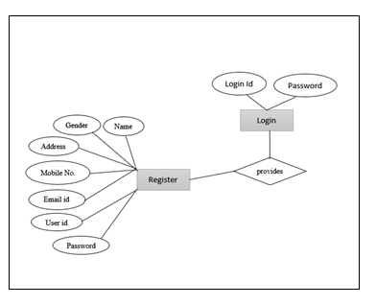
Fig 3.2 E-R Diagram

3.2 Data Dictionary
A Data Dictionary compiles names, definitions, and attributes concerning data elements utilized or stored within a database, information system, or part of a research project. It delineates the meanings and functions of data elements within the context of a project and offers guidance on understanding, recognizing meanings, and description. Additionally, a Data Dictionary offers metadata about data elements, aiding in defining the scope and attributes of data elements, as well as the guidelines for their usage and application.

Name | Type | Collation | Attributes | Null | Default
id | Int(11) | Latin_swedish_ci |  | No | None
User name | Varchar (30) | Latin_swedish_ci |  | No | None
email | Varchar (30) | Latin_swedish_ci |  | No
pswd | Varchar (30) | Latin_swedish_ci |  | No
phone no | Varchar (30) | Latin_swedish_ci |  | No
country | Varchar (30) | Latin_swedish_ci |  | No
state | Varchar (30) | Latin_swedish_ci |  | No

Table No. 3.2 Data Dictionary

Id | User name | email | pswd | phno | country | state | city
1 | vijay | vkappati@gmail.com | ******** | 6281407028 | India | AP | kurnool
2 | vinod | vinod@gmail.com | ******** | 8790557392 | India | AP | kurnool
3 | Ajay | ajay@gmail.com | ******** | 7780490892 | India | AP | mdk
4 | vishnu | Vishnu@gmail.com | ******** | 9849466191 | India | AP | rzp

Table No 3.2.1 Data Table
Id | Uname | Ureview | Sanalysis | Tname | Suggestion
1 | Kumar | The traffic for ambulance bad | False positive | Traffic | Better to avoid traffic
2 | kumar | Exam System is good fees students | False Negative | Exam | To know about exam
3 | Vinod | We can find more details in too and can view all | Malicious Bots | Sexual_assults | To know about sexual assaults
4 | Manjunath | This is excellent | False Negative | Carona_vacine | Consume all people
5 | Chinni | Invention if vaccine comes to | False Negative | IPL | Provide more information

Table No 3.2.2 Received User Data Analysis

Normalization
Normalization is the primary method for optimizing data in a database to fulfill two essential criteria:
Data dependencies are logical, ensuring that all related data items are stored together. Normalization is crucial for various reasons, primarily because it enables databases to occupy minimal disk space, resulting in enhanced performance.
Normalization is also referred to as data standardization.
The three primary types of normalization are outlined below.
Note: "NF" stands for "normal form."

First typical structure (1NF)
Tables in 1NF should comply with certain standards:
- Every cell should contain just a solitary (nuclear) esteem.
- Each part in the table ought to be astoundingly named.
- All characteristics in a part ought to connect with a comparative region.

UserID | Username | Password
015 | John | ********
016 | Princess | ********
027 | Tom | ********
028 | Claire | ********
029 | Robert | ********
Table No. 3.2.3 1NF

Second typical structure (2NF)
Tables in 2NF ought to be in 1NF and not have any most of the way dependence (e.g., each non-prime quality ought to be dependent upon the table's fundamental key).
User Id | Received Data through IOT | password | Login
1 | 11 | ******** | Sign_up
2 | 12 | ******** | Sign_up
3 | 13 | ******** | Sign_up
4 | 14 | ******** | Sign_up
5 | 15 | ******** | Sign_up

Table No 3.2.4 2NF
Third ordinary structure (3NF)
Tables in 3NF ought to be in 2NF and have no transitive reasonable circumstances on the fundamental key. The going with two NFs furthermore exists anyway are only here and there used:

USERDETAILS
ID | NAME | EMAIL | STATE | CITY | COUNTRY
11 | Vijay | vijay@gmail.com | AP | RZP | INDIA
12 | Vinod | vinod@gmail.com | AP | RZP | INDIA
13 | Ramu | Ramu@gmail.com | AP | RZP | INDIA
14 | Vishnu | vishnu@gmail.com | AP | RZP | INDIA
Table No. 3.2.5 User Details

USER DETAILS
USER ID | PASSSWORD | LOGIN
server | ******** | Sign_up
Vijay | ******** | Sign_up
Table No. 3.2.6 User details

Boyce-Codd Normal Form (BCNF)
Normalization is a critical process in database management aimed at organizing tables to minimize anomalies and ensure data integrity. It follows a series of stages known as normal forms. These normal forms help structure tables efficiently and reduce redundancy and inconsistency in data.

Unnormalized Form (UNF): The initial state of a table where data is not organized according to any specific rules.

First Normal Form (1NF): In 1NF, each column contains atomic values, and there are no repeating groups or arrays within a row.

Second Normal Form (2NF): 2NF requires that every non-key attribute be fully functionally dependent on the primary key.

Third Normal Form (3NF): In 3NF, no transitive dependencies should exist, meaning that non-key attributes should not depend on other non-key attributes.

Elementary Key Normal Form (EKNF): EKNF is a further refinement of 3NF, emphasizing the use of elementary keys.
Boyce-Codd Normal Form (BCNF): BCNF addresses anomalies that may arise when multiple candidate keys exist. It requires that for every non-trivial functional dependency (X → Y), X must be a superkey.
Fourth Normal Form (4NF): To achieve 4NF, a table must be in BCNF and should not have multi-valued dependencies.
Essential Tuple Normal Form (ETNF): ETNF is a condition where each attribute in a tuple is essential to the understanding of the tuple itself.

Normal Form | Description
1NF | An alliance is in 1NF enduring it contains an atomic worth.
2NF | An association will be in 2NF expecting it is in 1NF and all non-key credits are totally down to earth ward on the fundamental key.
3NF | An alliance will be in 3NF enduring it is in 2NF and no change dependence exists.
BCNF | A more grounded importance of 3NF is known as Boyce Codd's common design.
4NF | An association will be in 4NF expecting it is in Boyce Codd's commonplace construction and has no multi-regarded dependence.
5NF | An association is in 5NF. In case it is in 4NF and contains no join dependence, joining should be lossless.

Benefits of Normalization
Reduction of data redundancy: Normalization helps eliminate redundant data by organizing it efficiently across tables. Improved overall database organization: By structuring data according to normalization rules, databases become more organized and easier to manage. Data consistency within the database:
Normalization ensures that data remains consistent across tables, reducing the risk of inconsistencies. More flexible database design:
Normalization allows for more flexibility in database design, making it easier to accommodate changes and updates. Upholds the principle of data integrity: Normalization promotes data integrity by minimizing anomalies and ensuring accurate representation of data relationships.

Disadvantages of Normalization
Careless decomposition: If normalization is done without a clear understanding of user requirements, it can lead to excessive decomposition and unnecessary complexity in the database design.
Decreased performance: As tables are normalized to higher normal forms such as 4NF or 5NF, it may lead to decreased performance due to increased join operations and complexity in querying the database.

3.3 UML DIAGRAM’S INTRODUCTION
The unified modeling language allows the software engineer to express an analysis model using the modeling notation that is governed by a set of syntax, semantic and pragmatic rules. A UML system is represented using five different views that describe the system from distinctly different perspective.
UML is specifically constructed through two different domains they are:
- UML Analysis modeling, this focuses on the user model and structural model views of the system.
- UML design modeling, which focuses on the behavioral modeling, implementation modeling and environmental model views.

Why We Use UML in projects?
As the strategic value of software increases for many companies, the industry looks for techniques to automate the production of software and to improve quality and reduce cost and time-to-market. These techniques include component technology, visual programming, patterns and frameworks. Businesses also seek techniques to manage the complexity of systems as they increase in scope and scale. In particular, they recognize the need to solve recurring architectural problems, such as physical distribution, concurrency, replication, security, load balancing and fault tolerance. Additionally, the development for the World Wide Web, while making some things simpler, has exacerbated these architectural problems. The Unified Modeling Language (UML) was designed to respond to these needs. Simply, Systems design refers to the process of defining the architecture, components, modules, interfaces, and data for a system to satisfy specified requirements which can be done easily through UML diagrams.
In the project four basic UML diagrams have been explained among the following list:
- Class Diagram.
- Use Case Diagram.
- Sequence Diagram.
- Activity Diagram.
- Collaboration Diagram.
- Deployment Diagram.
- State Chart Diagram.
- Component Diagram.

Class Diagram
A Class diagram in the Unified Modeling Language (UML) is a type of static structure diagram that describes the structure of a system by showing the system's classes, their attributes, and the relationships between the classes.
This is one of the most important of the diagrams in development. The diagram breaks the class into three layers. One has the name, the second describes its attributes and the third its methods. A padlock to left of the name represents the private attributes. The relationships are drawn between the classes. Developers use the Class Diagram to develop the classes. Analyses use it to show the details of the system.
Architects look at class diagrams to see if any class has too many functions and see if they are required to be split.
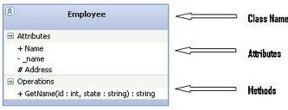

Fig 3.3.1: Class Diagram

Use Case Diagram

A Use Case diagram in the Unified Modeling Language (UML) is a type of behavioral diagram defined by and created from a Use-case analysis. Its purpose is to present a graphical overview of the functionality provided by a system in terms of actors, their goals (represented as use cases), and any dependencies between those use cases. The main purpose of a use case diagram is to show what system functions are performed for which actor. Roles of the actors in the system can be depicted. Use cases are used during requirements elicitation and analysis to represent the functionality of the system. Use cases focus on the behavior of the system from the external point of view. The actors are outside the boundary of the system, whereas the use cases are inside the boundary of the system.

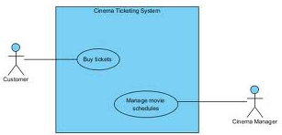
Fig 3.3.2: Use Case Diagram

Sequence Diagram
A Sequence diagram in Unified Modeling Language (UML) is a kind of interaction diagram that shows how processes operate with one another and in what order. It is a construct of a Message Sequence Chart. Sequence diagrams are sometimes called Event-trace diagrams, event scenarios, and timing diagrams
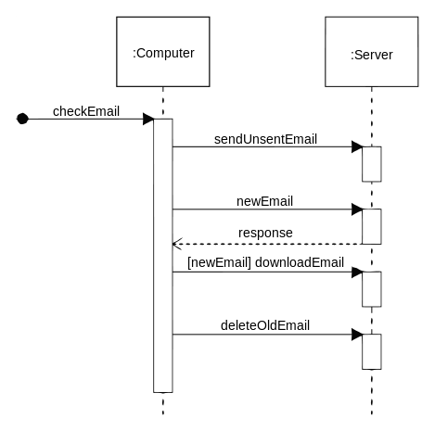

Fig 3.3.3: Sequence Diagram

Activity Diagram
Activity diagrams are a loosely defined diagram technique for showing workflows of stepwise activities and actions, with support for choice, iteration and concurrency. In the Unified Modeling Language, activity diagrams can be used to describe the business and operational step-by-step workflows of components in a system. An activity diagram shows the overall flow of control.
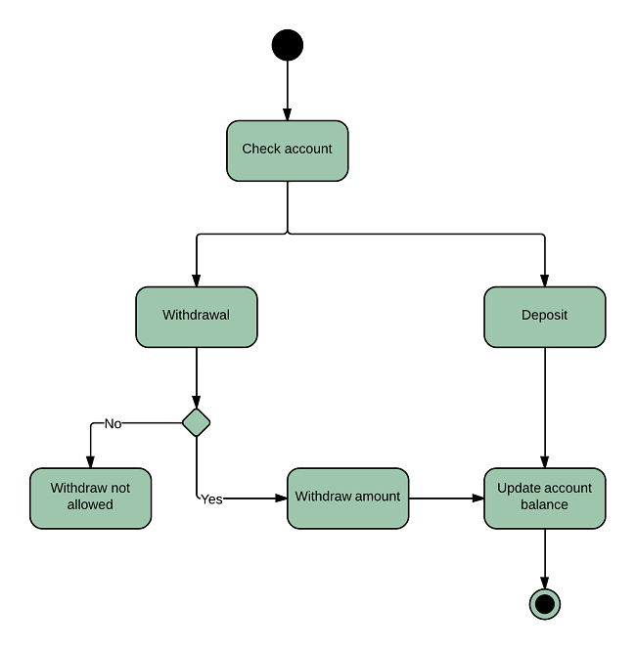Fig 3.3.4: Activity Diagram
Collaboration Diagram
A Communication diagram models the interactions between objects or parts in terms of sequenced messages. Communication diagrams represent a combination of information taken from Class, Sequence, and Use Case Diagrams describing both the static structure and dynamic behavior of a system.
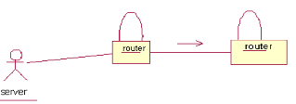

Fig 3.3.5: Collaboration Diagram

Deployment Diagram
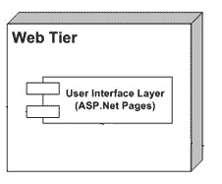
A Deployment diagram in the Unified Modeling Language models the physical deployment of artifacts on nodes. To describe a web site, for example, a deployment diagram would show what hardware components ("nodes") exist (e.g., a web server, an application server, and a database server), what software components ("artifacts") run on each node (e.g., web application, database), and how the different pieces are connected e.g. JDBC, REST

Fig 3.3.6: Deployment Diagram
State Chart Diagram
A State diagram is a type of diagram used in computer science and related fields to describe the behavior of systems. State diagrams require that the system described is composed of a finite number of states sometimes, this is indeed the case, while at other times this is a reasonable abstraction. Many forms of state diagrams exist, which differ slightly and have different semantics.
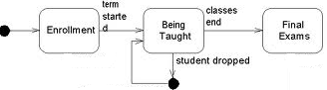

Fig 3.3.7: State Chart Diagram

Component Diagram
In the Unified Modeling Language, a component diagram depicts how components are wired together to form larger components and or software systems. They are used to illustrate the structure of arbitrarily complex systems.
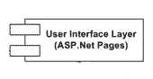

Fig 3.3.8: Component Diagram

DATA FLOW DIAGRAM
- The DFD is also called as bubble chart. It is a simple graphical formalism that can be used to represent a system in terms of input data to the system, various processing carried out on this data, and the output data is generated by this system.
- The data flow diagram (DFD) is one of the most important modeling tools. It is used to model the system components. These components are the system process, the data used by the process, an external entity that interacts with the system and the information flows in the system.
- DFD shows how the information moves through the system and how it is modified by a series of transformations. It is a graphical technique that depicts information flow and the transformations that are applied as data moves from input to output.
- DFD is also known as bubble chart. A DFD may be used to represent a system at any level of abstraction. DFD may be partitioned into levels that represent increasing information flow and functional detail.

DFD NOTATIONS

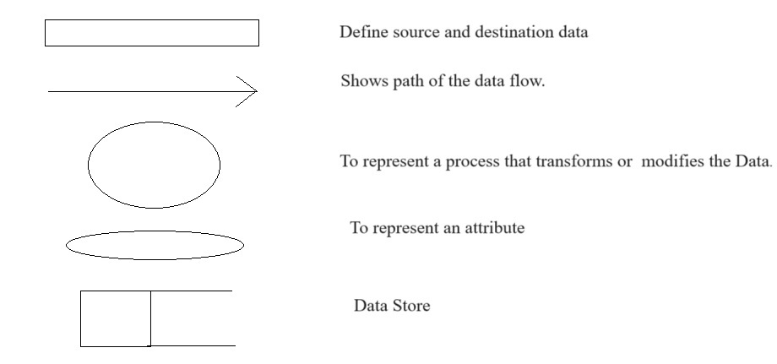

Fig 3.3.9: Data Flow Diagram

3.4 UML DIAGRAMS
UML stands for Unified Modeling Language. UML is a standardized general-purpose modeling language in the field of object-oriented software engineering. The standard is managed, and was created by, the Object Management Group.
The goal is for UML to become a common language for creating model object oriented computer software. In its current form UML is comprised of two major components: a Meta-model and a notation. In the future, some form of method or process may also be added to; or associated with, UML.
The Unified Modeling Language is a standard language for specifying, Visualization, Constructing and documenting the artifacts of software system, as well as for business modeling and other non-software systems.
The UML represents a collection of best engineering practices that have proven successful in the modeling of large and complex systems.
The UML is a very important part of developing objects oriented software and the software development process. The UML uses mostly graphical notations to express the design of software projects.

GOALS
The Primary goals in the design of the UML are as follows:
- Provide users a ready-to-use, expressive visual modeling Language so that they can develop and exchange meaningful models.
- Provide extendibility and specialization mechanisms to extend the core concepts.
- Be independent of particular programming languages and development process.
- Provide a formal basis for understanding the modeling language.
- Encourage the growth of OO tools market.
- Support higher level development concepts such as collaborations, frameworks, patterns and components.
- Integrate best practices.

3.4.1 USE CASE DIAGRAM
User
Input data
Preprocessing
Training
Classification
Fig 3.4.1: Use case Diagram for overall project

3.4.2 CLASS DIAGRAM
Input

Input data

Preprocessing ( )
Output

Features extraction
Classification

Finally get Classified &Display Result: BRAIN disease (positive or Negative)

Fig.3.4.2: Class Diagram for Overall Project

3.4.3 SEQUENCE DIAGRAM
A Sequence diagram in Unified Modeling Language (UML) is a kind of interaction diagram that shows how processes operate with one another and in what order. It is a construct of a Message Sequence Chart. Sequence diagrams are sometimes called event diagrams, event scenarios, and timing diagrams.

Datacollection
Training
Testing
Collect the data from the user feature on cnn
Send the data to the traing stage
Perforn Preprocessing
Train the data
Extracted feature with images sending to the testing stage
Give input
Predict the type using proposed algorithm
Fig 3.4.3: Sequence Diagram for Overall Project
3.4.4 ACTIVITY DIAGRAM
Input Data
Preprocessing
Training
Prediction using proposed CNN
Predicted Label As positive or negative
Fig 3.4.4: Activity Diagram
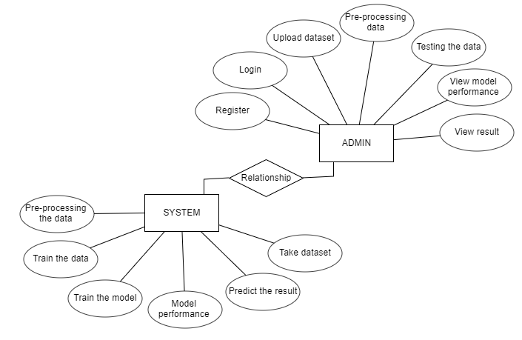
3.4.5 ER-DIAGRAM
Fig 3.4.5: ER- Diagram

TESTING
CHAPTER- 4
TESTING
4.1 TESTING METHODOLIGIES
Software Testing is a critical element of software quality assurance and represents the ultimate review of specification, design and coding, Testing presents an interesting anomaly for the software engineer.
4.1.1 Testing Objectives
- Testing is a process of executing a program with the intent of finding an error.
- A good test case is one that has a probability of finding an as yet
- undiscovered error.
- A successful test is one that uncovers an undiscovered error.
- These above objectives imply a dramatic change in view port.
Testing cannot show the absence of defects, it can only show that software errors are present.
4.1.2 Test Case Design
Any engineering product can be tested in one of two ways:
White Box Testing
This testing is also called as glass box testing. In this testing, by knowing the specified function that a product has been designed to perform test can be conducted that demonstrates each function is fully operation at the same time searching for errors in each function. It is a test case design method that uses the control structure of the procedural design to derive test cases. Basis path testing is a white box testing.

Basis Path Testing
- Flow graph notation.
- Cyclomatic Complexity.

Deriving test cases Control Structure Testing
- Condition testing.
- Data flow testing.
- Loop testing.

Black Box Testing
In this testing by knowing the internal operation of a product, tests can be conducted to ensure that “all gears mesh”, that is the internal operation performs according to specification and all internal components have been adequately exercised. It fundamentally focuses on the functional requirements of the software.
The steps involved in black box test case design are:
- Graph based testing methods.
- Equivalence partitioning.
- Boundary value analysis.
- Comparison testing.
- Graph matrices.

4.2 SOFTWARE TESTING STRATEGIES
A Strategy for software testing integrates software test cases into a series of well planned steps that result in the successful construction of software. Software testing is a broader topic for what is referred to as Verification and Validation. Verification refers to the set of activities that ensure that the software correctly implements a specific function. Validation refers he set of activities that ensure that the software that has been built is traceable to customer’s requirements.

4.2.1 Unit Testing
Unit testing focuses verification effort on the smallest unit of software design that is the module. Using procedural design description as a guide, important control paths are tested to uncover errors within the boundaries of the module. The unit test is normally white box testing oriented and the step can be conducted in parallel for multiple modules.

4.2.2 Integration Testing
Integration testing is a systematic technique for constructing the program structure, while conducting test to uncover errors associated with the interface. The objective is to take unit tested methods and build a program structure that has been dictated by design.

Top-Down Integration
Top-down integrations is an incremental approach for construction of program structure. Modules are integrated by moving downward through the control hierarchy, beginning with the main control program. Modules subordinate to the main program are incorporated in the structure either in the breath-first or depth-first manner.

Bottom-up Integration
This method as the name suggests, begins construction and testing with atomic modules i.e., modules at the lowest level. Because the modules are integrated in the bottom up manner the processing required for the modules subordinate to a given level is always available and the need for stubs is eliminated.

Regression Testing
In this contest of an integration test strategy, regression testing is the re execution of some subset of test that have already been conducted to ensure that changes have not propagate unintended side effects.
4.2.3 Validation Testing
At the end of integration testing software is completely assembled as a package. Validation testing is the next stage, which can be defined as successful when the software functions in the manner reasonably expected by the customer. Reasonable expectations are those defined in the software requirements specifications. Information contained in those sections form a basis for validation testing approach.
Reasonable expectation is defined in the software requirement specification – a document that describes all user-visible attributes of the software. The specification contains a section titled “Validation Criteria”. Information contained in that section forms the basis for a validation testing approach.
Validation Test Criteria
Software validation is achieved through a series of black-box tests that demonstrate conformity with requirement. A test plan outlines the classes of tests to be conducted, and a test procedure defines specific test cases that will be used in an attempt to uncover errors in conformity with requirements. Both the plan and procedure are designed to ensure that all functional requirements are satisfied, all performance requirements are achieved, documentation is correct and human-engineered; and other requirements are met.
After each validation test case has been conducted, one of two possible conditions exists: (1) The function or performance characteristics conform to specification and are accepted, or (2) a deviation from specification is uncovered and a deficiency list is created. Deviation or error discovered at this stage in a project can rarely be corrected prior to scheduled completion. It is often necessary to negotiate with the customer to establish a method for resolving deficiencies.
Alpha and Beta Testing
It is virtually impossible for a software developer to foresee how the customer will really use a program. Instructions for use may be misinterpreted. Strange combination of data may be regularly used; and output that seemed clear to the tester may be unintelligible to a user in the field.
When custom software is built for one customer, a series of acceptance tests are conducted to enable the customer to validate all requirements. Conducted by the end user rather than the system developer, an acceptance test can range from an informal “test drive” to a planned and systematically executed series of tests. In fact, acceptance testing can be conducted over a period of weeks or months, thereby uncovering cumulative errors that might degrade the system over time.
The beta test is conducted at one or more customer sites by the end user of the software. Unlike alpha testing, the developer is generally not present. Therefore, the beta test is a “live” application of the software in an environment that cannot be controlled by the developer. The customer records all problems that are encountered during beta testing and reports these to the developer at regular intervals. As a result of problems reported during beta test, the software developer makes modification and then prepares for release of the software product to the entire customer base.

4.2.4 System Testing
System testing is actually a series of different tests whose primary purpose is to fully exercise the computer-based system. Although each test has a different purpose, all work to verify that all system elements have been properly integrated to perform allocated functions.

4.2.5 Security Testing
Attempts to verify the protection mechanisms built into the system.

4.2.6 Performance Testing
This method is designed to test runtime performance of software within the context of an integrated system.

4.3 TEST CASES
S. No. | TEST CASES | INPUT | EXPECTED RESULT | ACTUAL RESULT | STATUS
1 | User Registration | Enter all fields | User gets registered | Registration  is successful | pass
2 | User Registration | if user miss any field | User not registered | Registration is  un successful | fail
3 | Admin Login | Give the user name and password | Admin home page should  be opened | Admin home Page has been opened | Pass
4 | Upload brain Dataset | Test whether the brain Dataset is uploaded or not into the system | If brain Dataset is not uploaded | We cannot do further operations | brain Dataset uploaded we will do further operations
5 | Preprocess Dataset | Verify the Dataset is Per – processed or not | Without loading the dataset | We cannot Per- processing Dataset | We Can Pre-process Dataset successfully
6 | Run CNN algorithm | Verify the CNN algorithm will run or not | Without training model | We cannot run CNN algorithm | We can run CNN algorithm

Table 4.3.1: Test Case Results

IMPLEMENTATION

CHAPTER-5
IMPLEMENTATION

5.1 Python

Below are some facts about Python. Python is currently the most widely used multi-purpose, high-level programming language. Python allows programming in Object-Oriented and Procedural paradigms. Python programs generally are smaller than other programming languages like Java. Programmers have to type relatively less and indentation requirement of the language, makes them readable all the time. Python language is being used by almost all tech-giant companies like – Google, Amazon, Facebook, Instagram, Dropbox, Uber… etc. The biggest strength of Python is huge collection of standard libraries which can be used for the following.

Machine Learning

GUI Applications (like Kivy, Tkinter, PyQt etc.)

Web frameworks like Django (used by YouTube, Instagram, Dropbox)

Image processing (like Opencv, Pillow)

Web scraping (like Scrapy, BeautifulSoup, Selenium)

Test frameworks

Multimedia

Advantages of Python

Let’s see how Python dominates over other languages.

1. Extensive Libraries

Python downloads with an extensive library and it contain code for various purposes like regular expressions, documentation-generation, unit-testing, web browsers, threading, databases, CGI, email, image manipulation, and more. So, we don’t have to write the complete code for that manually.

2. Extensible
As we have seen earlier, Python can be extended to other languages. You can write some of your code in languages like C++ or C. This comes in handy, especially in projects.

3. Embeddable

Complimentary to extensibility, Python is embeddable as well. You can put your Python code in your source code of a different language, like C++. This lets us add scripting capabilities to our code in the other language.

4. Improved Productivity

The language’s simplicity and extensive libraries render programmers more productive than languages like Java and C++ do. Also, the fact that you need to write less and get more things done.

5. IOT Opportunities

Since Python forms the basis of new platforms like Raspberry Pi, it finds the future bright for the Internet Of Things. This is a way to connect the language with the real world.

6. Simple and Easy

When working with Java, you may have to create a class to print ‘Hello World’. But in Python, just a print statement will do. It is also quite easy to learn, understand, and code. This is why when people pick up Python, they have a hard time adjusting to other more verbose languages like Java.

7. Readable

Because it is not such a verbose language, reading Python is much like reading English. This is the reason why it is so easy to learn, understand, and code. It also does not need curly braces to define blocks, and indentation is mandatory. This further aids the readability of the code.

How to Install Python on Windows and Mac:
There have been several updates in the Python version over the years. The question is how to install Python? It might be confusing for the beginner who is willing to start learning Python but this tutorial will solve your query. The latest or the newest version of Python is version 3.7.4 or in other words, it is Python 3.
Note: The python version 3.7.4 cannot be used on Windows XP or earlier devices.
Before you start with the installation process of Python. First, you need to know about your System Requirements. Based on your system type i.e. operating system and based processor, you must download the python version. My system type is a Windows 64-bit operating system. So the steps below are to install python version 3.7.4 on Windows 7 device or to install Python 3. Download the Python Cheatsheet here.The steps on how to install Python on Windows 10, 8 and 7 are divided into 4 parts to help understand better.

Download the Correct version into the system
Step 1: Go to the official site to download and install python using Google Chrome or any other web browser. OR Click on the following link: https://www.python.org
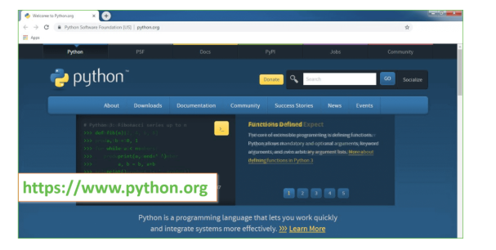
Now, check for the latest and the correct version for your operating system.
Step 2: Click on the Download Tab.

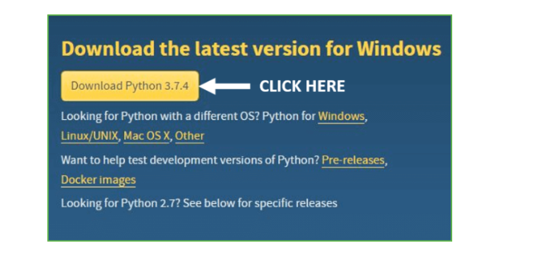

Step 3: You can either select the Download Python for windows 3.7.4 button in Yellow Color or you can scroll further down and click on download with respective to their version. Here, we are downloading the most recent python version for windows 3.7.4

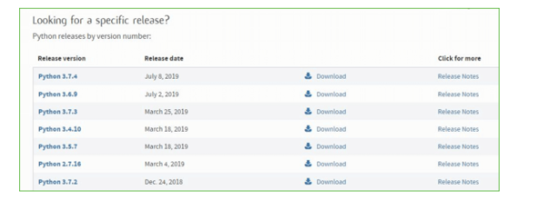

Step 4: Scroll down the page until you find the Files option.

Step 5: Here you see a different version of python along with the operating system.

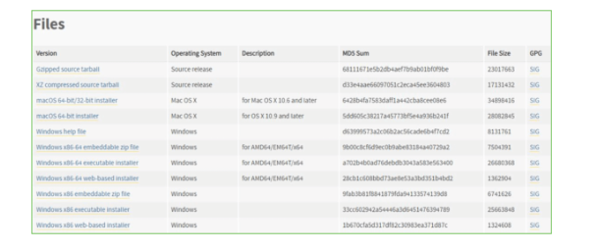

Installation of Python
Step 1: Go to Download and Open the downloaded python version to carry out the installation process.

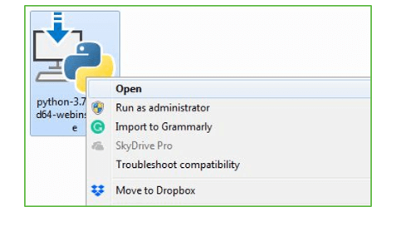

Step 2: Before you click on Install Now, Make sure to put a tick on Add Python 3.7 to PATH.

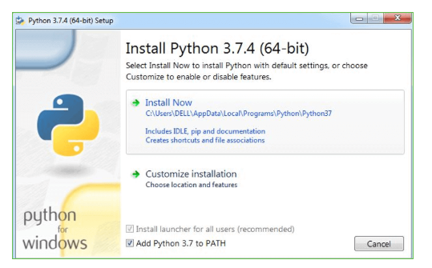

Step 3: Click on Install NOW After the installation is successful. Click on Close.


With these above three steps on python installation, you have successfully and correctly installed Python. Now is the time to verify the installation.
Note: The installation process might take a couple of minutes.

Verify the Python Installation

Step 1: Click on Start
Step 2: In the Windows Run Command, type “cmd”.

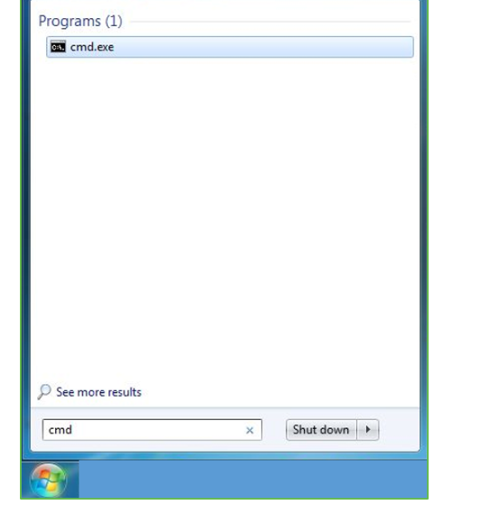

Step 3: Open the Command prompt option.
Step 4: Let us test whether the python is correctly installed. Type python –V and press Enter.

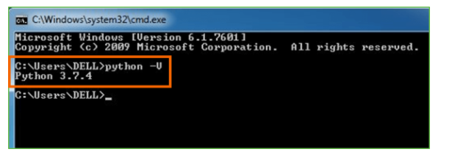

Step 5: You will get the answer as 3.7.4
Note: If you have any of the earlier versions of Python already installed. You must first uninstall the earlier version and then install the new one.

Check how the Python IDLE works

Step 1: Click on Start
Step 2: In the Windows Run command, type “python idle”.

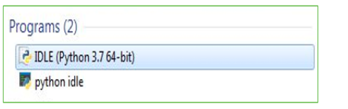

Step 3: Click on IDLE (Python 3.7 64-bit) and launch the program
Step 4: To go ahead with working in IDLE you must first save the file. Click on File > Click on Save

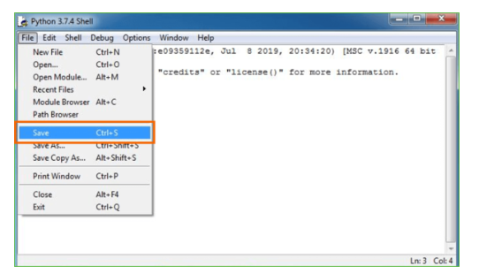
Step 5: Name the file and save as type should be Python files. Click on SAVE. Here I have named the files as Hey World.

  - Sample Screens

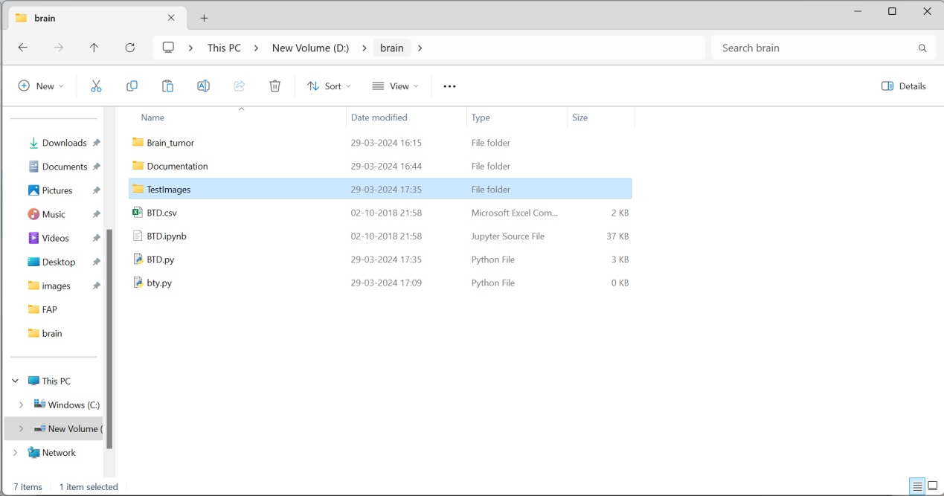

Screen 1: Home Page of Project

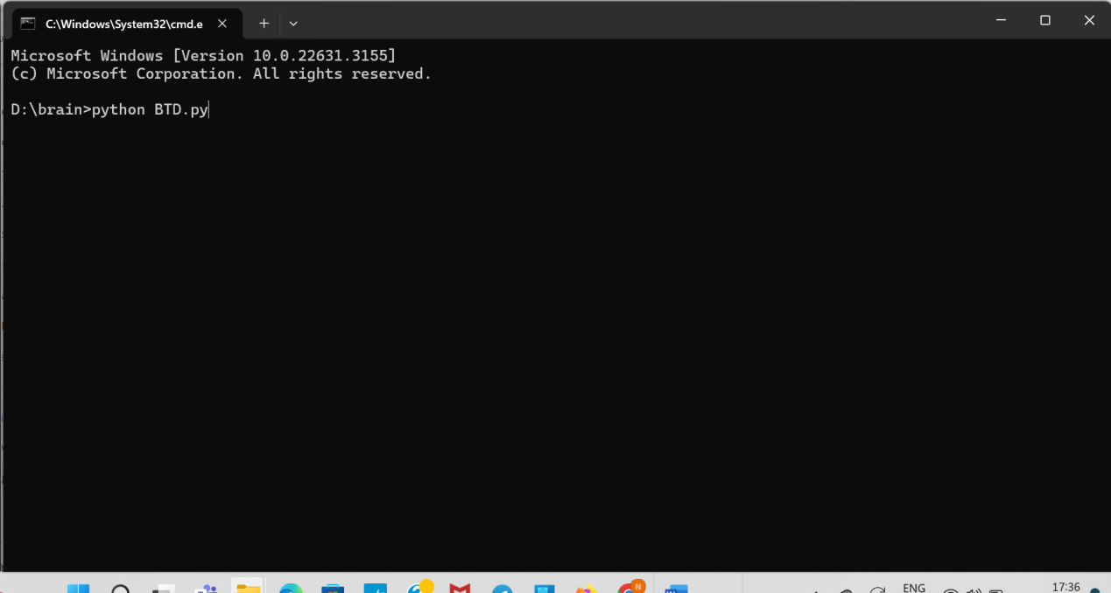

Screen 2: Run Project

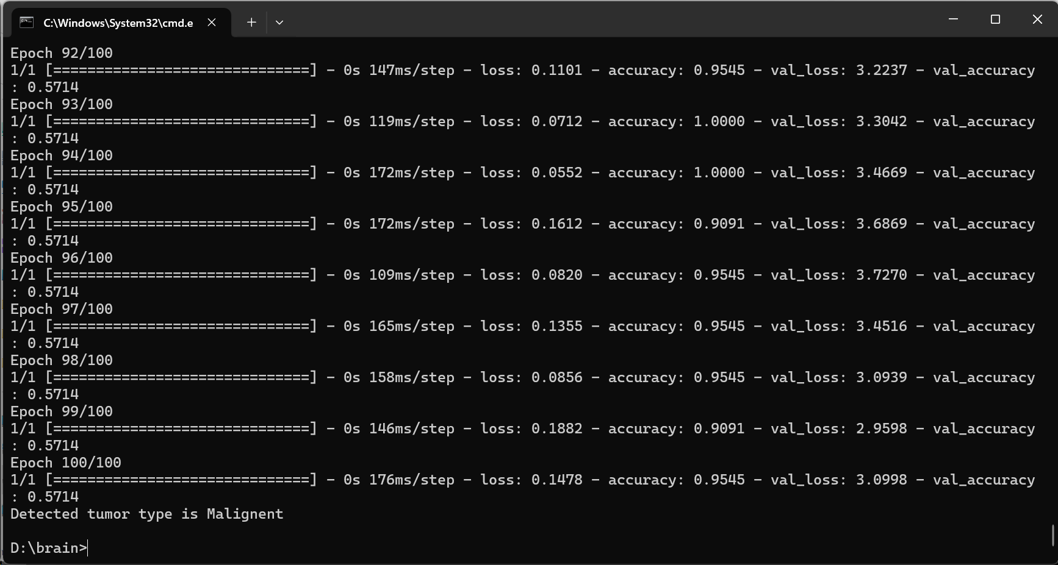

Screen 3: Trained Datasets

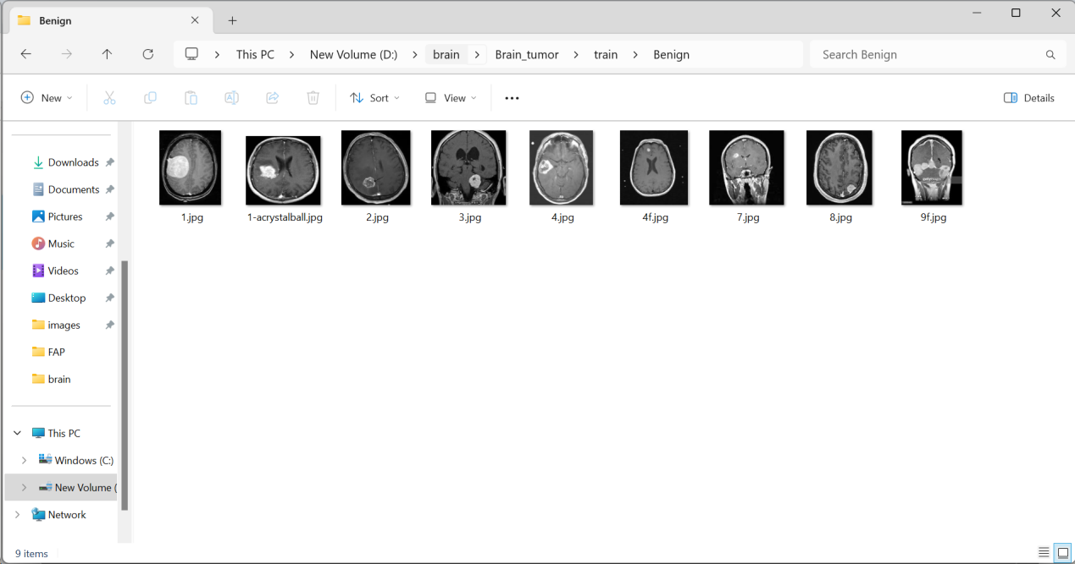

Screen 4: Trained Datasets with Images

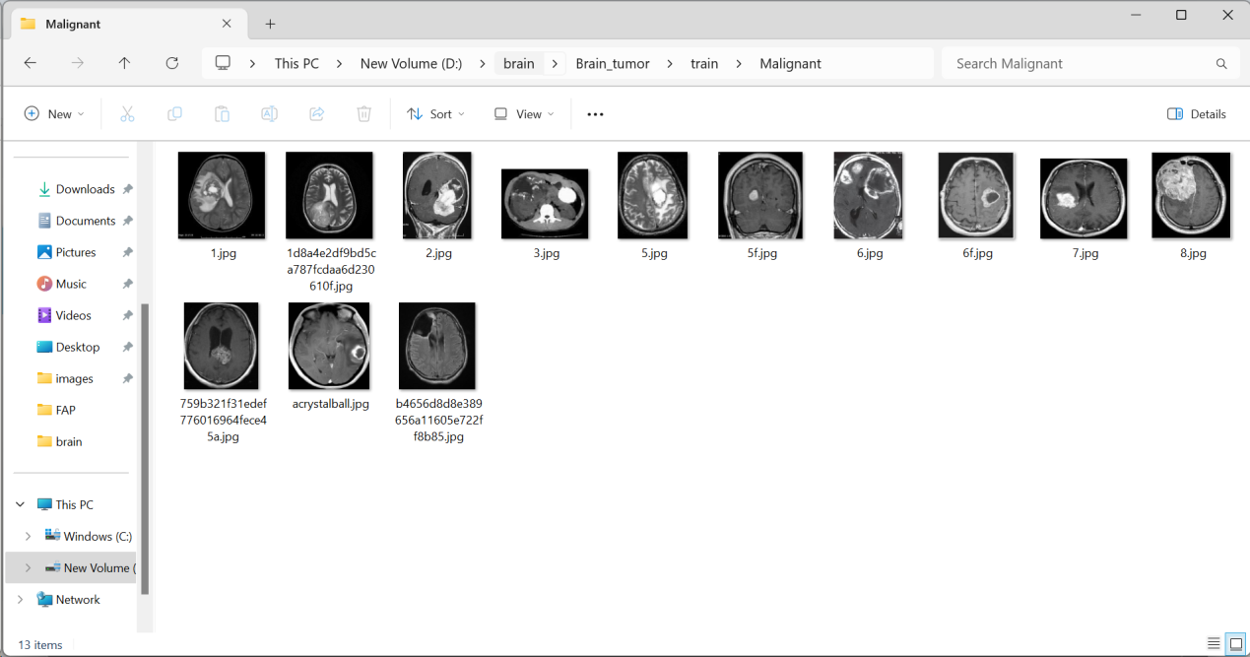

Screen 5: Select a Image and Predict

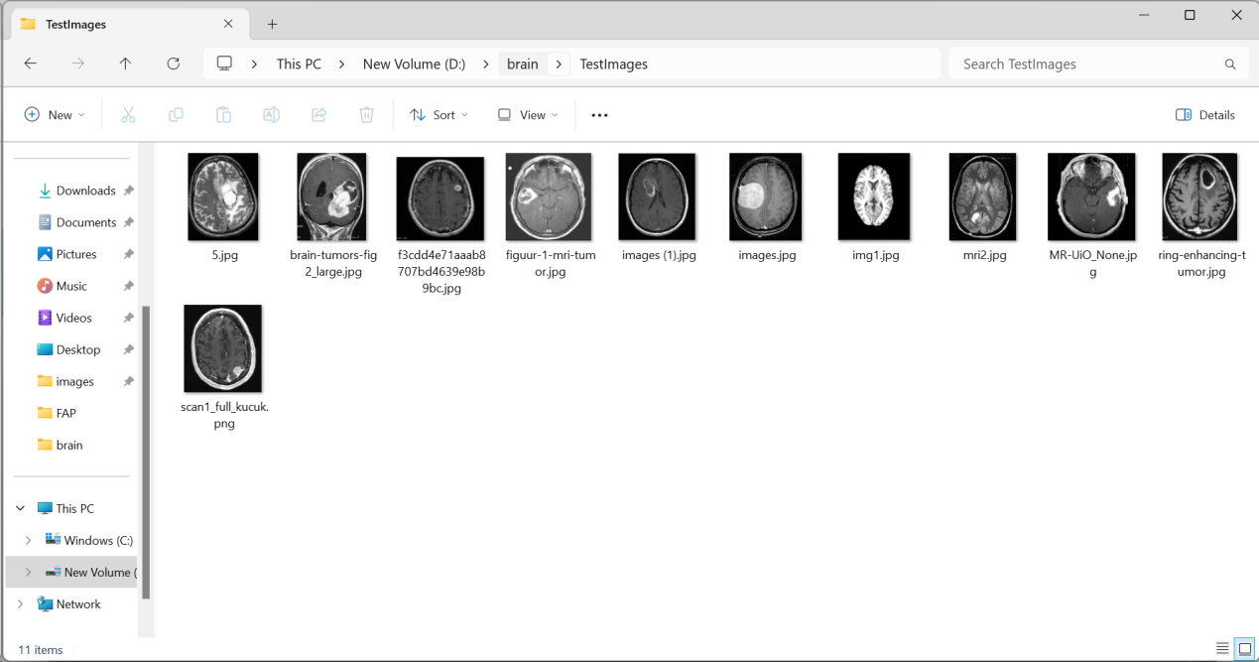

Screen 6: Predicted Tumor

Step 6: Now for e.g. enter print.

CONCLUSION

CHAPTER- 6
6.1 CONCLUSION
A recurring theme in machine learning is the limit imposed by the lack of labelled datasets, which hampers training and task performance. Conversely, it is acknowledged that more data improves performance, as Sun et al. [85] shows using an internal Google dataset of 300 million images. In general computer vision tasks, attempts have been made to circumvent limited data by using smaller filters on deeper layers [47], with novel CNN architecture combinations [86], or hyperparameter optimization [87]. In medical image analysis, the lack of data is two-fold and more acute: there is general lack of publicly available data, and high quality labelled data is even more scarce. Most of the datasets presented in this review involve fewer than 100 patients. Yet the situation may not be as dire as it seems, as despite the small training datasets, the papers in this review report relatively satisfactory performance in the various tasks. The question of how many images are necessary for training in medical image analysis was partially answered by Cho et al. [88]. He ascertained the accuracy of a CNN with GoogLeNet architecture in classifying individual axial CT images into one of 6 body regions: brain, neck, shoulder, chest, abdomen, pelvis. With 200 training images, accuracies of 88-98% were achieved on a test set of 6000 images. While categorization into various body regions is not a realistic medical image analysis task, his report does suggest that the problem may be surmountable. Being able to accomplish classification with a small dataset is possibly due to the general intrinsic image homogeneity across different patients, as opposed to the near-infinite variety of natural images, such as a dog in various breeds, colors and poses. VAEs and GANS, being generative models, may sidestep the data paucity problem, by creating synthetic medical data. This was done by Guibas and Virdi, who used a 2 stage GAN to segment and then generate retinal fundus images successfully [89]. Their work was built on the research of Costa et al. [90], which first described using GANs to generate retinal fundus images. Aside from synthetic data generation, GANs have been used in brain MRI segmentation as well by Moeskops et al. [91], Kamnitsas et al. [92] and Alex et al. [93]. Data or class imbalance in the training set is also a significant issue in medical image analysis [94]. This refers to the number of images in the training data being skewed towards normal and non-pathological images. Rare diseases are an extreme example of this and can be missed without adequate training examples.

6.2. FUTURE SCOPE
This data imbalance effect can be ameliorated by using data augmentation to generate more training images of rare or abnormal data, though there is risk of overfitting. Aside from data-level strategies, algorithmic modification strategies and cost sensitive learning have also been studied [95], [96]. An important, non-technical challenge is the public reception towards their health results being studied by a nonhuman actor. This situation is not helped by the apocalyptic artificial intelligence scenarios painted by some. Machine learning algorithms have surpassed human performance in image recognition tasks, and it is likely that they will perform better than humans in medical image analysis as well. Indeed, some of the papers in this review report that dermatologists and radiologists have already been bested by machine learning. Yet the question regarding legal and moral culpability arises when a patient is misdiagnosed, or suffers morbidity as a result of AI or AI-assisted medical management. This is accentuated by our inability to fully explain how the blackbox of machine algorithms work. However, it is likely that our relationship will continue evolve and recalibrate as AI-based technologies mature and inexorably permeate different facets of our lives.

BIBLIOGRAPHY

BIBLIOGRAPHY

[1] C.-J. Hsiao, E. Hing, and J. Ashman, ‘‘Trends in electronic health record
system use among office-based physicians: United states, 2007–2012,’’
Nat. Health Stat. Rep., vol. 75, pp. 1–18, May 2014.
[2] R. Smith-Bindman et al., ‘‘Use of diagnostic imaging studies and associated radiation exposure for patients enrolled in large integrated health care systems, 1996–2010,’’ JAMA, vol. 307, no. 22, pp. 2400–2409, 2012.
[3] E. H. Shortliffe, Computer-Based Medical Consultations: MYCIN, vol. 2. New York, NY, USA: Elsevier, 1976.
[4] G. Litjens et al. (Jun. 2017). ‘‘A survey on deep learning in medical image analysis.’’ [Online]. Available: https://arxiv.org/abs/1702.05747
[5] W. S. McCulloch and W. Pitts, ‘‘A logical calculus of the ideas immanent in nervous activity,’’ Bull. Math. Biol., vol. 5, nos. 4, pp. 115–133, 1943.
[6] F. Rosenblatt, ‘‘The perceptron: A probabilistic model for information
storage and organization in the brain,’’ Psychol. Rev., vol. 65, no. 6,
pp. 365–386, 1958.
[7] D. H. Hubel and T. N. Wiesel, ‘‘Receptive fields, binocular interaction and functional architecture in the cat’s visual cortex,’’ J. Physiol., vol. 160,
no. 1, pp. 106–154, 1962.
[8] K. Fukushima and S. Miyake, ‘‘Neocognitron: A self-organizing neural
network model for a mechanism of visual pattern recognition,’’ in Competition and Cooperation in Neural Nets. Berlin, Germany: Springer, 1982, pp. 267–285.
[9] Y. LeCun et al., ‘‘Backpropagation applied to handwritten zip code
recognition,’’ Neural Comput., vol. 1, no. 4, pp. 541–551, 1989.
[10] D. E. Rumelhart, G. E. Hinton, and R. J. Williams, ‘‘Learning representations by back-propagating errors,’’ Nature, vol. 323, pp. 533–536,
Oct. 1986.
[11] A. Krizhevsky, I. Sutskever, and G. E. Hinton, ‘‘ImageNet classification with deep convolutional neural networks,’’ in Proc. Adv. Neural Inf. Process. Syst., 2012, pp. 1097–1105.
[12] D. Shen, G. Wu, and H.-I. Suk, ‘‘Deep learning in medical
image analysis,’’ Annu. Rev. Biomed. Eng., vol. 19, pp. 221–248,
Mar. 2017.
[13] K. Suzuki, ‘‘Overview of deep learning in medical imaging,’’ Radiol.
Phys. Technol., vol. 10, no. 3, pp. 257–273, 2017.
[14] H. Greenspan, B. van Ginneken, and R. M. Summers, ‘‘Guest editorial deep learning in medical imaging: Overview and future promise of an exciting new technique,’’ IEEE Trans. Med. Imag., vol. 35, no. 5, pp. 1153–1159, May 2016.
[15] D. Adams. (2017). Publish or Perish 5. Accessed: Oct. 30, 2017. [Online]. Available: https://harzing.com/resources/publish-or-perish/windows
[16] K. Clark et al., ‘‘The cancer imaging archive (TCIA): Maintaining and
operating a public information repository,’’ J. Digit. Imag., vol. 26, no. 6,
pp. 1045–1057, 2013.
[17] X. Wang, Y. Peng, L. Lu, Z. Lu, M. Bagheri, and R. M. Summers.
(Dec. 2017). ‘‘ChestX-ray8: Hospital-scale chest X-ray database and
benchmarks on weakly-supervised classification and localization of common thorax diseases.’’ [Online]. Available: https://arxiv.org/abs/1705.
02315
[18] E. Gibson et al. (Oct. 2017). ‘‘NiftyNet: A deep-learning platform for
medical imaging.’’ [Online]. Available: https://arxiv.org/abs/1709.03485
[19] O. Ronneberger, P. Fischer, and T. Brox, ‘‘U-net: Convolutional networks for biomedical image segmentation,’’ in Proc. Int. Conf. Med. Image Comput. Comput.-Assist. Intervent., 2015, pp. 234–241.
[20] F. Milletari, N. Navab, and S.-A. Ahmadi, ‘‘V-net: Fully convolutional
neural networks for volumetric medical image segmentation,’’ in Proc.
4th Int. Conf. 3D Vis. (3DV), Oct. 2016, pp. 565–571.
[21] K. Kamnitsas et al., ‘‘Efficient multi-scale 3D CNN with fully connected CRF for accurate brain lesion segmentation,’’ Med. Image Anal., vol. 36, pp. 61–78, Feb. 2017.
[22] I. Goodfellow, Y. Bengio, and A. Courville, Deep Learning. Cambridge, MA, USA: MIT Press, 2016.
[23] O. Russakovsky et al., ‘‘ImageNet large scale visual recognition challenge,’’ Int. J. Comput. Vis., vol. 115, no. 3, pp. 211–252, Dec. 2015, doi: 10.1007/s11263-015-0816-y.
[24] H.-C. Shin et al., ‘‘Deep convolutional neural networks for computeraided detection: CNN architectures, dataset characteristics and transfer learning,’’ IEEE Trans. Med. Imag., vol. 35, no. 5, pp. 1285–1298,
May 2016.
[25] H. Ravishankar et al., ‘‘Understanding the mechanisms of deep transfer
learning for medical images,’’ in Proc. Int. Workshop Large-Scale Annotation Biomed. Data Expert Label Synthesis, 2016, pp. 188–196.
[26] N. Tajbakhsh et al., ‘‘Convolutional neural networks for medical image
analysis: Full training or fine tuning?’’ IEEE Trans. Med. Imag., vol. 35,
no. 5, pp. 1299–1312, May 2016.
[27] I. Sutskever, J. Martens, and G. E. Hinton, ‘‘Generating text with recurrent neural networks,’’ in Proc. 28th Int. Conf. Mach. Learn. (ICML), 2011, pp. 1017–1024.
[28] A. Karpathy and L. Fei-Fei, ‘‘Deep visual-semantic alignments for generating image descriptions,’’ in Proc. IEEE Conf. Comput. Vis. Pattern
Recognit., Jun. 2015, pp. 3128–3137.
[29] J. Chen, L. Yang, Y. Zhang, M. Alber, and D. Z. Chen, ‘‘Combining
fully convolutional and recurrent neural networks for 3D biomedical
image segmentation,’’ in Proc. Adv. Neural Inf. Process. Syst., 2016,
pp. 3036–3044.
[30] M. F. Stollenga, W. Byeon, M. Liwicki, and J. Schmidhuber, ‘‘Parallel
multi-dimensional LSTM, with application to fast biomedical volumetric
image segmentation,’’ in Proc. Adv. Neural Inf. Process. Syst., 2015,
pp. 2998–3006.

APPENDIX – A

URL LISTING
  - www.google.co.in
  - www.python.org
  - www.w3schools.com
  - www.pythontutorial.com

REFERENCE BOOKS
- Python Crash Course 2nd Edition - this is a basic level book for beginners.
- Learning python 5th Edition - this book is a practical learning book for basic to advanced level.
- Python Cookbook - this book for advanced programmer interested in learning about modern python development tools.
- Automating Boring Stuff With Python - In this book you will learn to write programs in python.
- Head First Python - this book covered the fundamental of python.
Think Python - the basics of programming concepts and cover advanced topics like data structure and object-oriented design.

APPENDIX – B

GLOSSARY
  - GUI : Graphical User Interface
  - UML : Unified Modeling Language
  - API : Application Programming Interface
  - HTML : Hyper Text Markup Language
  - URL : Uniform Resource Locator
  - ODBC : Open Database Connectivity

APPENDIX – C

- List of Figures
S.NO | Fig No | Description | Page No | Chapter
1 | 2.2.1 | System Architecture | 12 | SRS
2 | 3.1 | ER-Model | 27 | System  Design
3 | 3.3.1 | Class Diagram | 42 | System  Design
4 | 3.3.2 | Use Case Diagram | 42 | System  Design
5 | 3.3.3 | Sequence diagram | 43 | System  Design
6 | 3.3.4 | Activity diagram | 43 | System  Design
7 | 3.3.5 | Collaboration Diagram | 44 | System  Design
8 | 3.3.6 | Deployment Diagram | 44 | System  Design
9 | 3.3.7 | State Chart Diagram | 45 | System  Design
10 | 3.3.8 | Component Diagram | 45 | System  Design
11 | 3.3.9 | Data Flow Diagram | 47 | System  Design
12 | 3.4.1 | Use Case for Overall Project | 48 | System  Design
13 | 3.4.2 | Class diagram for overall project | 49 | System  Design
14 | 3.4.3 | Sequence diagram for overall Project | 49 | System  Design
15 | 3.4.4 | Activity diagram | 50 | System  Design
16 | 3.4.5 | ER- Diagram for overall project | 50 | System  Design

- List of Tables
S. No | Table No | Table Name | Page No | Chapter
1 | 3.2 | Data Dictionary | 34 | System Design
2 | 3.2.1 | Data Table | 34 | System Design
3 | 3.2.2 | Received user Data Analysis | 35 | System Design
4 | 3.2.3 | 1NF | 36 | System Design
5 | 3.2.4 | 2NF | 36 | System Design
6 | 3.2.5 | User Details | 37 | System Design
7 | 3.2.6 | User Details | 37 | System Design
7 | 4.3.1 | Test cases results | 56 | Testing

- List of Screens

S No. | Screen  No. | Screen Name | Page  No. | Chapter
1 | 1 | Home page of project | 65 | Implementation
2 | 2 | Run project | 65 | Implementation
3 | 3 | Trained Dataset | 66 | Implementation
4 | 4 | Trained Dataset with Images | 66 | Implementation
5 | 5 | Select a Image and Predict | 67 | Implementation
6 | 6 | Predicted Tumor | 67 | Implementation

CODING

APPENDIX – D
- Coding
# coding: utf-8
# In[1]:

import tensorflow as tf
import keras
from keras.models import Sequential
from keras.layers import Conv2D
from keras.layers import MaxPooling2D
from keras.layers import Flatten
from keras.layers import Dense
from tkinter import messagebox
from tkinter import *
from tkinter import simpledialog
import tkinter
from tkinter import filedialog
import matplotlib.pyplot as plt
import numpy as np
from tkinter.filedialog import askopenfilename
import os
import cv2
from sklearn.model_selection import train_test_split
from sklearn.metrics import accuracy_score
import imutils
from keras.utils.np_utils import to_categorical
from keras.layers import MaxPooling2D
from keras.layers import Dense, Dropout, Activation, Flatten
from keras.layers import Convolution2D
from keras.models import Sequential
from keras.models import model_from_json
import pickle
from sklearn import metrics
import ftplib
from tkinter import ttk

main = tkinter.Tk()
main.title("BRAIN TUMOR DETECTION USING MACHINE LEARNING") #designing main screen
main.geometry("1300x1200")

global filename
global accuracy
X = []
Y = []
global classifier
disease = ['No Tumor Detected','Tumor Detected']

def upload(): #function to upload tweeter profile
global filename
filename = filedialog.askdirectory(initialdir=".")
text.delete('1.0', END)
text.insert(END,filename+" loaded\n");
def generateModel():
global X
global Y
X.clear()
Y.clear()
if os.path.exists('Model/myimg_data.txt.npy'):
X = np.load('Model/myimg_data.txt.npy')
Y = np.load('Model/myimg_label.txt.npy')
else:
for root, dirs, directory in os.walk(filename+"/no"):
for i in range(len(directory)):
name = directory[i]
img = cv2.imread(filename+"/no/"+name,0)
ret2,th2 = cv.threshold(img,0,255,cv.THRESH_BINARY+cv.THRESH_OTSU)
img = cv2.resize(img, (128,128))
im2arr = np.array(img)
im2arr = im2arr.reshape(128,128,1)
X.append(im2arr)
Y.append(0)
print(filename+"/no/"+name)

for root, dirs, directory in os.walk(filename+"/yes"):
for i in range(len(directory)):
name = directory[i]
img = cv2.imread(filename+"/yes/"+name,0)
ret2,th2 = cv.threshold(img,0,255,cv.THRESH_BINARY+cv.THRESH_OTSU)
img = cv2.resize(img, (128,128))
im2arr = np.array(img)
im2arr = im2arr.reshape(128,128,1)
X.append(im2arr)
Y.append(1)
print(filename+"/yes/"+name)

X = np.asarray(X)
Y = np.asarray(Y)
np.save("Model/myimg_data.txt",X)
np.save("Model/myimg_label.txt",Y)
print(X.shape)
print(Y.shape)
print(Y)
cv2.imshow('ss',X[20])
cv2.waitKey(0)
text.insert(END,"Total number of images found in dataset : "+str(len(X))+"\n")
text.insert(END,"Total number of classes : "+str(len(set(Y)))+"\n\n")

def CNN():
global accuracy
global classifier

YY = to_categorical(Y)
indices = np.arange(X.shape[0])
np.random.shuffle(indices)
x_train = X[indices]
y_train = YY[indices]

if os.path.exists('Model/model.json'):
with open('Model/model.json', "r") as json_file:
loaded_model_json = json_file.read()
classifier = model_from_json(loaded_model_json)

classifier.load_weights("Model/model_weights.h5")
classifier._make_predict_function()
print(classifier.summary())
f = open('Model/history.pckl', 'rb')
data = pickle.load(f)
f.close()
acc = data['accuracy']
accuracy = acc[9] * 100
text.insert(END,'\n\nCNN Model Generated. See black console to view layers of CNN\n\n')
text.insert(END,"CNN Prediction Accuracy on Test Images : "+str(accuracy)+"\n")
else:
X_trains, X_tests, y_trains, y_tests = train_test_split(x_train, y_train, test_size = 0.2, random_state = 0)
classifier = Sequential() #alexnet transfer learning code here
classifier.add(Convolution2D(32, 3, 3, input_shape = (128, 128, 1), activation = 'relu'))
classifier.add(MaxPooling2D(pool_size = (2, 2)))
classifier.add(Convolution2D(32, 3, 3, activation = 'relu'))
classifier.add(MaxPooling2D(pool_size = (2, 2)))
classifier.add(Flatten())
classifier.add(Dense(output_dim = 128, activation = 'relu'))
classifier.add(Dense(output_dim = 2, activation = 'softmax'))
print(classifier.summary())
classifier.compile(optimizer = 'adam', loss = 'categorical_crossentropy', metrics = ['accuracy'])
hist = classifier.fit(x_train, y_train, batch_size=16, epochs=10,validation_split=0.2, shuffle=True, verbose=2)
classifier.save_weights('Model/model_weights.h5')
model_json = classifier.to_json()
with open("Model/model.json", "w") as json_file:
json_file.write(model_json)
f = open('Model/history.pckl', 'wb')
pickle.dump(hist.history, f)
f.close()
f = open('Model/history.pckl', 'rb')
data = pickle.load(f)
f.close()
acc = data['accuracy']
accuracy = acc[9] * 100
text.insert(END,'\n\nCNN Model Generated. See black console to view layers of CNN\n\n')
text.insert(END,"CNN Prediction Accuracy on Test Images : "+str(accuracy)+"\n")

def predict():
ftp = ftplib.FTP_TLS("ftp.drivehq.com")
ftp.login("sanakavyalakshmi", "123@anvesh")
ftp.prot_p()
name = imagelist.get()
with open('drivehq.jpg', 'wb' ) as file :
ftp.retrbinary('RETR %s' % name, file.write)
file.close()

img = cv2.imread('drivehq.jpg',0)
img = cv2.resize(img, (128,128))
im2arr = np.array(img)
im2arr = im2arr.reshape(1,128,128,1)
XX = np.asarray(im2arr)

predicts = classifier.predict(XX)
print(predicts)
cls = np.argmax(predicts)
print(cls)
img = cv2.imread('drivehq.jpg')
img = cv2.resize(img, (800,500))
cv2.putText(img, 'Disease Identified as : '+disease[cls], (10, 25), cv2.FONT_HERSHEY_SIMPLEX,0.7, (0, 255, 255), 2)
cv2.imshow('Disease Identified as : '+disease[cls], img)
cv2.waitKey(0)

def getImages():
ftp = ftplib.FTP_TLS("ftp.drivehq.com")
ftp.login("sanakavyalakshmi", "123@anvesh")
ftp.prot_p()
filenames = ftp.nlst()
value.clear()
for filename in filenames:
value.append(filename)

font = ('times', 16, 'bold')
title = Label(main, text='BRAIN TUMOR DETECTION USING MACHINE LEARNING')
title.config(bg='darkviolet', fg='gold')
title.config(font=font)
title.config(height=3, width=120)
title.place(x=0,y=5)

font1 = ('times', 12, 'bold')
text=Text(main,height=20,width=150)
scroll=Scrollbar(text)
text.configure(yscrollcommand=scroll.set)
text.place(x=50,y=120)
text.config(font=font1)

font1 = ('times', 12, 'bold')
uploadButton = Button(main, text="Upload MRI Images Dataset", command=upload)
uploadButton.place(x=50,y=550)
uploadButton.config(font=font1)

modelButton = Button(main, text="Generate Images Train & Test Model", command=generateModel)
modelButton.place(x=290,y=550)
modelButton.config(font=font1)

cnnButton = Button(main, text="Generate Deep Learning CNN Model", command=CNN)
cnnButton.place(x=710,y=550)
cnnButton.config(font=font1)

imageButton = Button(main, text="Get DriveHQ Images", command=getImages)
imageButton.place(x=50,y=600)
imageButton.config(font=font1)

value = ["DriveHQ Images"]
imagelist = ttk.Combobox(main,values=value,postcommand=lambda: imagelist.configure(values=value))
imagelist.place(x=240,y=600)
imagelist.current(0)
imagelist.config(font=font1)

predictButton = Button(main, text="Predict Tumor", command=predict)
predictButton.place(x=440,y=600)
predictButton.config(font=font1)

main.config(bg='turquoise')
main.mainloop()

# In[2]:
classifier = Sequential()
# Input layer
classifier.add(Conv2D(32, (3, 3), input_shape = (64, 64, 3), activation = 'relu'))

# In[3]:

classifier.add(MaxPooling2D(pool_size = (2, 2)))
# Hidden layer 1
classifier.add(Conv2D(32, (3, 3), activation = 'relu'))
classifier.add(MaxPooling2D(pool_size = (2, 2)))

# Hidden layer 2
classifier.add(Conv2D(32, (3, 3), activation = 'relu'))
classifier.add(MaxPooling2D(pool_size = (2, 2)))

# Hidden layer 3
classifier.add(Flatten())

# Hidden layer 4
classifier.add(Dense(activation = 'relu',units=128))
classifier.add(Dense(activation = 'sigmoid',units=1))

classifier.compile(optimizer = 'adam', loss = 'binary_crossentropy', metrics = ['accuracy'])
classifier.summary()

# In[4]:

from keras.preprocessing.image import ImageDataGenerator

train_datagen = ImageDataGenerator(rescale = 1./255,
shear_range = 0.2,
zoom_range = 0.2,
horizontal_flip = True)

test_datagen = ImageDataGenerator(rescale = 1./255)

from tkinter import messagebox
from tkinter import *
from tkinter import simpledialog
import tkinter
from tkinter import filedialog
import matplotlib.pyplot as plt
import numpy as np
from tkinter.filedialog import askopenfilename
import os
import cv2
from sklearn.model_selection import train_test_split
from sklearn.metrics import accuracy_score
import imutils
from keras.utils.np_utils import to_categorical
from keras.layers import MaxPooling2D
from keras.layers import Dense, Dropout, Activation, Flatten
from keras.layers import Convolution2D
from keras.models import Sequential
from keras.models import model_from_json
import pickle
from sklearn import metrics
import ftplib
from tkinter import ttk

main = tkinter.Tk()
main.title("BRAIN TUMOR DETECTION USING MACHINE LEARNING") #designing main screen
main.geometry("1300x1200")

global filename
global accuracy
X = []
Y = []
global classifier
disease = ['No Tumor Detected','Tumor Detected']

def upload(): #function to upload tweeter profile
global filename
filename = filedialog.askdirectory(initialdir=".")
text.delete('1.0', END)
text.insert(END,filename+" loaded\n");

def generateModel():
global X
global Y
X.clear()
Y.clear()
if os.path.exists('Model/myimg_data.txt.npy'):
X = np.load('Model/myimg_data.txt.npy')
Y = np.load('Model/myimg_label.txt.npy')
else:
for root, dirs, directory in os.walk(filename+"/no"):
for i in range(len(directory)):
name = directory[i]
img = cv2.imread(filename+"/no/"+name,0)
ret2,th2 = cv.threshold(img,0,255,cv.THRESH_BINARY+cv.THRESH_OTSU)
img = cv2.resize(img, (128,128))
im2arr = np.array(img)
im2arr = im2arr.reshape(128,128,1)
X.append(im2arr)
Y.append(0)
print(filename+"/no/"+name)

for root, dirs, directory in os.walk(filename+"/yes"):
for i in range(len(directory)):
name = directory[i]
img = cv2.imread(filename+"/yes/"+name,0)
ret2,th2 = cv.threshold(img,0,255,cv.THRESH_BINARY+cv.THRESH_OTSU)
img = cv2.resize(img, (128,128))
im2arr = np.array(img)
im2arr = im2arr.reshape(128,128,1)
X.append(im2arr)
Y.append(1)
print(filename+"/yes/"+name)

X = np.asarray(X)
Y = np.asarray(Y)
np.save("Model/myimg_data.txt",X)
np.save("Model/myimg_label.txt",Y)
print(X.shape)
print(Y.shape)
print(Y)
cv2.imshow('ss',X[20])
cv2.waitKey(0)
text.insert(END,"Total number of images found in dataset : "+str(len(X))+"\n")
text.insert(END,"Total number of classes : "+str(len(set(Y)))+"\n\n")

def CNN():
global accuracy
global classifier

YY = to_categorical(Y)

indices = np.arange(X.shape[0])
np.random.shuffle(indices)

x_train = X[indices]
y_train = YY[indices]

if os.path.exists('Model/model.json'):
with open('Model/model.json', "r") as json_file:
loaded_model_json = json_file.read()
classifier = model_from_json(loaded_model_json)

classifier.load_weights("Model/model_weights.h5")
classifier._make_predict_function()
print(classifier.summary())
f = open('Model/history.pckl', 'rb')
data = pickle.load(f)
f.close()
acc = data['accuracy']
accuracy = acc[9] * 100
text.insert(END,'\n\nCNN Model Generated. See black console to view layers of CNN\n\n')
text.insert(END,"CNN Prediction Accuracy on Test Images : "+str(accuracy)+"\n")
else:
X_trains, X_tests, y_trains, y_tests = train_test_split(x_train, y_train, test_size = 0.2, random_state = 0)
classifier = Sequential() #alexnet transfer learning code here
classifier.add(Convolution2D(32, 3, 3, input_shape = (128, 128, 1), activation = 'relu'))
classifier.add(MaxPooling2D(pool_size = (2, 2)))
classifier.add(Convolution2D(32, 3, 3, activation = 'relu'))
classifier.add(MaxPooling2D(pool_size = (2, 2)))
classifier.add(Flatten())
classifier.add(Dense(output_dim = 128, activation = 'relu'))
classifier.add(Dense(output_dim = 2, activation = 'softmax'))
print(classifier.summary())
classifier.compile(optimizer = 'adam', loss = 'categorical_crossentropy', metrics = ['accuracy'])
hist = classifier.fit(x_train, y_train, batch_size=16, epochs=10,validation_split=0.2, shuffle=True, verbose=2)
classifier.save_weights('Model/model_weights.h5')
model_json = classifier.to_json()
with open("Model/model.json", "w") as json_file:
json_file.write(model_json)
f = open('Model/history.pckl', 'wb')
pickle.dump(hist.history, f)
f.close()
f = open('Model/history.pckl', 'rb')
data = pickle.load(f)
f.close()
acc = data['accuracy']
accuracy = acc[9] * 100
text.insert(END,'\n\nCNN Model Generated. See black console to view layers of CNN\n\n')
text.insert(END,"CNN Prediction Accuracy on Test Images : "+str(accuracy)+"\n")

def predict():
ftp = ftplib.FTP_TLS("ftp.drivehq.com")
ftp.login("sanakavyalakshmi", "123@anvesh")
ftp.prot_p()
name = imagelist.get()
with open('drivehq.jpg', 'wb' ) as file :
ftp.retrbinary('RETR %s' % name, file.write)
file.close()

img = cv2.imread('drivehq.jpg',0)
img = cv2.resize(img, (128,128))
im2arr = np.array(img)
im2arr = im2arr.reshape(1,128,128,1)
XX = np.asarray(im2arr)

predicts = classifier.predict(XX)
print(predicts)
cls = np.argmax(predicts)
print(cls)
img = cv2.imread('drivehq.jpg')
img = cv2.resize(img, (800,500))
cv2.putText(img, 'Disease Identified as : '+disease[cls], (10, 25), cv2.FONT_HERSHEY_SIMPLEX,0.7, (0, 255, 255), 2)
cv2.imshow('Disease Identified as : '+disease[cls], img)
cv2.waitKey(0)

def getImages():
ftp = ftplib.FTP_TLS("ftp.drivehq.com")
ftp.login("sanakavyalakshmi", "123@anvesh")
ftp.prot_p()
filenames = ftp.nlst()
value.clear()
for filename in filenames:
value.append(filename)

font = ('times', 16, 'bold')
title = Label(main, text='BRAIN TUMOR DETECTION USING MACHINE LEARNING')
title.config(bg='darkviolet', fg='gold')
title.config(font=font)
title.config(height=3, width=120)
title.place(x=0,y=5)

font1 = ('times', 12, 'bold')
text=Text(main,height=20,width=150)
scroll=Scrollbar(text)
text.configure(yscrollcommand=scroll.set)
text.place(x=50,y=120)
text.config(font=font1)

font1 = ('times', 12, 'bold')
uploadButton = Button(main, text="Upload MRI Images Dataset", command=upload)
uploadButton.place(x=50,y=550)
uploadButton.config(font=font1)

modelButton = Button(main, text="Generate Images Train & Test Model", command=generateModel)
modelButton.place(x=290,y=550)
modelButton.config(font=font1)

cnnButton = Button(main, text="Generate Deep Learning CNN Model", command=CNN)
cnnButton.place(x=710,y=550)
cnnButton.config(font=font1)

imageButton = Button(main, text="Get DriveHQ Images", command=getImages)
imageButton.place(x=50,y=600)
imageButton.config(font=font1)

value = ["DriveHQ Images"]
imagelist = ttk.Combobox(main,values=value,postcommand=lambda: imagelist.configure(values=value))
imagelist.place(x=240,y=600)
imagelist.current(0)
imagelist.config(font=font1)

predictButton = Button(main, text="Predict Tumor", command=predict)
predictButton.place(x=440,y=600)
predictButton.config(font=font1)

main.config(bg='turquoise')
main.mainloop()

# In[5]:

import os
os.getcwd()
os.chdir('F:/AI PROJECTS/2018 projects/2018 IEEE/Brain_tumor/Brain_tumor')
print(os.getcwd())

# In[6]:

training_set = train_datagen.flow_from_directory('F:/AI PROJECTS/2018 projects/2018 IEEE/Brain_tumor/Brain_tumor/train/',
target_size = (64, 64),
batch_size = 32,
class_mode = 'binary')

test_set = test_datagen.flow_from_directory('F:/AI PROJECTS/2018 projects/2018 IEEE/Brain_tumor/Brain_tumor/test/',
target_size = (64, 64),
batch_size = 32,
class_mode = 'binary')

# In[7]:

classifier.fit_generator(training_set, steps_per_epoch=None, epochs=100, verbose=1, callbacks=None, validation_data=test_set, validation_steps=None, class_weight=None, max_queue_size=10, workers=1, use_multiprocessing=False, shuffle=True, initial_epoch=0)

# In[8]:

import numpy as np
from keras.preprocessing import image
test_image = image.load_img('F:/AI PROJECTS/2018 projects/2018 IEEE/Brain_tumor/TestImages/figuur-1-mri-tumor.jpg', target_size = (64, 64))
test_image

# In[10]:

test_image = image.img_to_array(test_image)
test_image = np.expand_dims(test_image, axis = 0)
test_image

from tkinter import messagebox
from tkinter import *
from tkinter import simpledialog
import tkinter
from tkinter import filedialog
import matplotlib.pyplot as plt
import numpy as np
from tkinter.filedialog import askopenfilename
import os
import cv2
from sklearn.model_selection import train_test_split
from sklearn.metrics import accuracy_score
import imutils
from keras.utils.np_utils import to_categorical
from keras.layers import MaxPooling2D
from keras.layers import Dense, Dropout, Activation, Flatten
from keras.layers import Convolution2D
from keras.models import Sequential
from keras.models import model_from_json
import pickle
from sklearn import metrics
import ftplib
from tkinter import ttk

main = tkinter.Tk()
main.title("BRAIN TUMOR DETECTION USING MACHINE LEARNING") #designing main screen
main.geometry("1300x1200")

global filename
global accuracy
X = []
Y = []
global classifier
disease = ['No Tumor Detected','Tumor Detected']

def upload(): #function to upload tweeter profile
global filename
filename = filedialog.askdirectory(initialdir=".")
text.delete('1.0', END)
text.insert(END,filename+" loaded\n");

def generateModel():
global X
global Y
X.clear()
Y.clear()
if os.path.exists('Model/myimg_data.txt.npy'):
X = np.load('Model/myimg_data.txt.npy')
Y = np.load('Model/myimg_label.txt.npy')
else:
for root, dirs, directory in os.walk(filename+"/no"):
for i in range(len(directory)):
name = directory[i]
img = cv2.imread(filename+"/no/"+name,0)
ret2,th2 = cv.threshold(img,0,255,cv.THRESH_BINARY+cv.THRESH_OTSU)
img = cv2.resize(img, (128,128))
im2arr = np.array(img)
im2arr = im2arr.reshape(128,128,1)
X.append(im2arr)
Y.append(0)
print(filename+"/no/"+name)

for root, dirs, directory in os.walk(filename+"/yes"):
for i in range(len(directory)):
name = directory[i]
img = cv2.imread(filename+"/yes/"+name,0)
ret2,th2 = cv.threshold(img,0,255,cv.THRESH_BINARY+cv.THRESH_OTSU)
img = cv2.resize(img, (128,128))
im2arr = np.array(img)
im2arr = im2arr.reshape(128,128,1)
X.append(im2arr)
Y.append(1)
print(filename+"/yes/"+name)

X = np.asarray(X)
Y = np.asarray(Y)
np.save("Model/myimg_data.txt",X)
np.save("Model/myimg_label.txt",Y)
print(X.shape)
print(Y.shape)
print(Y)
cv2.imshow('ss',X[20])
cv2.waitKey(0)
text.insert(END,"Total number of images found in dataset : "+str(len(X))+"\n")
text.insert(END,"Total number of classes : "+str(len(set(Y)))+"\n\n")

def CNN():
global accuracy
global classifier

YY = to_categorical(Y)

indices = np.arange(X.shape[0])
np.random.shuffle(indices)

x_train = X[indices]
y_train = YY[indices]

if os.path.exists('Model/model.json'):
with open('Model/model.json', "r") as json_file:
loaded_model_json = json_file.read()
classifier = model_from_json(loaded_model_json)

classifier.load_weights("Model/model_weights.h5")
classifier._make_predict_function()
print(classifier.summary())
f = open('Model/history.pckl', 'rb')
data = pickle.load(f)
f.close()
acc = data['accuracy']
accuracy = acc[9] * 100
text.insert(END,'\n\nCNN Model Generated. See black console to view layers of CNN\n\n')
text.insert(END,"CNN Prediction Accuracy on Test Images : "+str(accuracy)+"\n")
else:
X_trains, X_tests, y_trains, y_tests = train_test_split(x_train, y_train, test_size = 0.2, random_state = 0)
classifier = Sequential() #alexnet transfer learning code here
classifier.add(Convolution2D(32, 3, 3, input_shape = (128, 128, 1), activation = 'relu'))
classifier.add(MaxPooling2D(pool_size = (2, 2)))
classifier.add(Convolution2D(32, 3, 3, activation = 'relu'))
classifier.add(MaxPooling2D(pool_size = (2, 2)))
classifier.add(Flatten())
classifier.add(Dense(output_dim = 128, activation = 'relu'))
classifier.add(Dense(output_dim = 2, activation = 'softmax'))
print(classifier.summary())
classifier.compile(optimizer = 'adam', loss = 'categorical_crossentropy', metrics = ['accuracy'])
hist = classifier.fit(x_train, y_train, batch_size=16, epochs=10,validation_split=0.2, shuffle=True, verbose=2)
classifier.save_weights('Model/model_weights.h5')
model_json = classifier.to_json()
with open("Model/model.json", "w") as json_file:
json_file.write(model_json)
f = open('Model/history.pckl', 'wb')
pickle.dump(hist.history, f)
f.close()
f = open('Model/history.pckl', 'rb')
data = pickle.load(f)
f.close()
acc = data['accuracy']
accuracy = acc[9] * 100
text.insert(END,'\n\nCNN Model Generated. See black console to view layers of CNN\n\n')
text.insert(END,"CNN Prediction Accuracy on Test Images : "+str(accuracy)+"\n")

def predict():
ftp = ftplib.FTP_TLS("ftp.drivehq.com")
ftp.login("sanakavyalakshmi", "123@anvesh")
ftp.prot_p()
name = imagelist.get()
with open('drivehq.jpg', 'wb' ) as file :
ftp.retrbinary('RETR %s' % name, file.write)
file.close()

img = cv2.imread('drivehq.jpg',0)
img = cv2.resize(img, (128,128))
im2arr = np.array(img)
im2arr = im2arr.reshape(1,128,128,1)
XX = np.asarray(im2arr)

predicts = classifier.predict(XX)
print(predicts)
cls = np.argmax(predicts)
print(cls)
img = cv2.imread('drivehq.jpg')
img = cv2.resize(img, (800,500))
cv2.putText(img, 'Disease Identified as : '+disease[cls], (10, 25), cv2.FONT_HERSHEY_SIMPLEX,0.7, (0, 255, 255), 2)
cv2.imshow('Disease Identified as : '+disease[cls], img)
cv2.waitKey(0)

def getImages():
ftp = ftplib.FTP_TLS("ftp.drivehq.com")
ftp.login("sanakavyalakshmi", "123@anvesh")
ftp.prot_p()
filenames = ftp.nlst()
value.clear()
for filename in filenames:
value.append(filename)

font = ('times', 16, 'bold')
title = Label(main, text='BRAIN TUMOR DETECTION USING MACHINE LEARNING')
title.config(bg='darkviolet', fg='gold')
title.config(font=font)
title.config(height=3, width=120)
title.place(x=0,y=5)

font1 = ('times', 12, 'bold')
text=Text(main,height=20,width=150)
scroll=Scrollbar(text)
text.configure(yscrollcommand=scroll.set)
text.place(x=50,y=120)
text.config(font=font1)

font1 = ('times', 12, 'bold')
uploadButton = Button(main, text="Upload MRI Images Dataset", command=upload)
uploadButton.place(x=50,y=550)
uploadButton.config(font=font1)

modelButton = Button(main, text="Generate Images Train & Test Model", command=generateModel)
modelButton.place(x=290,y=550)
modelButton.config(font=font1)

cnnButton = Button(main, text="Generate Deep Learning CNN Model", command=CNN)
cnnButton.place(x=710,y=550)
cnnButton.config(font=font1)

imageButton = Button(main, text="Get DriveHQ Images", command=getImages)
imageButton.place(x=50,y=600)
imageButton.config(font=font1)

value = ["DriveHQ Images"]
imagelist = ttk.Combobox(main,values=value,postcommand=lambda: imagelist.configure(values=value))
imagelist.place(x=240,y=600)
imagelist.current(0)
imagelist.config(font=font1)

predictButton = Button(main, text="Predict Tumor", command=predict)
predictButton.place(x=440,y=600)
predictButton.config(font=font1)

main.config(bg='turquoise')
main.mainloop()

# In[11]:

result = classifier.predict(test_image)
result

# In[12]:

training_set.class_indices

# In[13]:

if result[0][0] == 0:
prediction = 'Benign'
else:
prediction = 'Malignent'
print("Detected tumor type is %s"%prediction)

